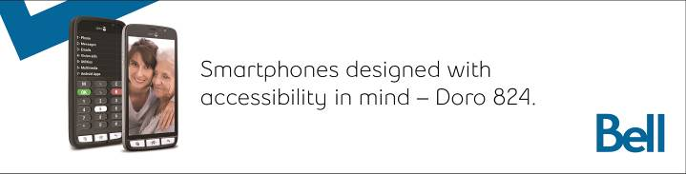

VISIONS

Canadian Council of the Blind

Newsletter

March 2019

“A lack of sight is

not a lack of vision”

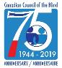
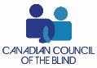

President’s Message++
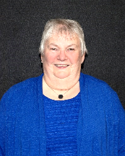
As winter, hopefully, is winding down we will be ready to SPRING ahead with our clocks this month. This time of year is busy with many chapters working on a variety of programs.

One of the items we have been working on is a survey on Accessibility and Assistive Technology in the job and in the process of working towards employment.
1 Louise Gillis

Click here to complete the survey!

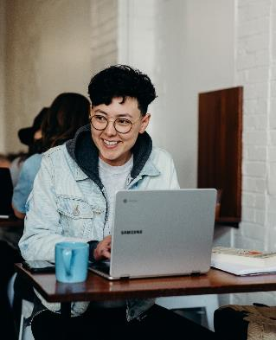
If you haven’t already completed the survey please do so as the closing date is March 15th. Thank you if you have already completed it. The results will be posted when they become available. As an organization “of the Blind” we want to make every effort so that persons with sight loss will not be overlooked in the job market.

(Le sondage est disponible en français sur notre site Web. www.ccbnational.net)

Speaking of surveys did you do the one from AMI in February’s newsletter? Once the survey is completed, your name will be entered into a draw to win $100! Thank you, in advance, for your cooperation. If you have any questions, kindly e-mail panel@ami.ca. http://amiresearchregistration.com/

In February, B-C 81 (Accessible Canada Act) was presented to the Senate for second reading. There are something’s such as time frames lacking but it is very important to get this bill passed and to Royal Assent prior to the summer recess. It is expected that we will have an opportunity to speak to or submit to the committee during these next number of weeks.

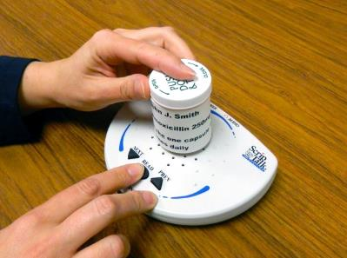
I have mentioned in previous Visions Newsletter about Script Talk and now bring it up again as Sobeys Pharmacies (•Safeway, FreshCo, Chalo FreshCo, IGA, Lawtons Drugs, Foodland, Price Chopper, Thrifty Foods, & Co-op, depending where you live) are now making the devices available at no cost for persons who are blind and partially sighted. If you wish to have your prescriptions prepared in this manner please contact our office so that we can let Sobeys management know of the location so they can prepare to make it available to you. This little device can prevent accidental mixing up of medication when a person is not able to read the labels.

Check out the many stories and technology ideas in this edition. Send any stories on your winter activities to our office for inclusion in future editions.

Louise Gillis,
National President

Announcements

The 2019 White Cane Week ‘Experience’ Expo: In Review++

On Saturday, February 2, the CCB Toronto Visionaries Chapter hosted what has become a calendar highlight for the blind and partially-sighted community in Toronto: the White Cane Week ‘Experience’ Expo.

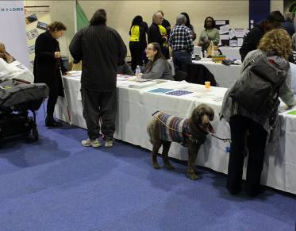Now in its fourth year, the 2019 ‘Experience’ Expo was a fantastic success on every level! With a record 46 exhibitors, over 300 attendees, a packed house for our first-ever Assistive Technology Forum, and dozens of door prize giveaways, this year’s ‘Experience’ Expo surpassed the 2018 Expo by every measure.

A lot of thought and hard work went into the preparation and planning of the event, and accessibility was at the top of the list.

“Opening the doors for everyone and making the Expo accessible has always been a priority for us,” said Ian White, CCB Toronto Visionaries Chapter President. “We’ve really tried to build in the kinds of amenities that will make visitors and exhibitors alike feel comfortable.” With event programs in both readable print and braille, a 3D printed tactile version of the exhibition hall floor plan, large-print exhibitor table cards with braille to identify individual exhibitors, and over 50 sighted guides available to assist with guidance and live-description of the exhibit space, there was a lot of thought given to welcoming everyone to the Expo. Even the aisles in the exhibit hall were planned to be wide enough to accommodate people with guide dogs, canes, and mobility devices.
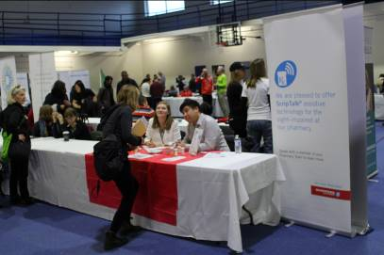
Visitors to the Expo were able to make their own choices about what information they’d like to focus on and to get to the exhibitors that most interested them independently, or with a little help if needed.

The venue, the Miles Nadal Jewish Community Centre (MNJCC), was chosen for its central downtown location close to accessible public transit and for being a fully-accessible, inclusive facility with ramps and elevators, accessible washrooms, and a deep commitment to making all visitors feel welcome. “We wanted everybody, whether sighted or living with vision loss, to be able to come out and enjoy the show,” White said, “and to get connected with the amazing variety of resources out there that can really make a difference in the lives of blind and partially-sighted people.”

To remove all barriers and to address the limited financial resources of many in the vision loss community, the CCB Toronto Visionaries Chapter consciously decided to make admission to the Expo completely free of charge. “We want everyone to be able to access the resources they need in order to end the social isolation that often accompanies a disability,” said White. “But we wouldn’t be able to open the doors to everyone without the generous support of our corporate partners.” Presenting sponsors Accessible Media Inc. (AMI), Bell Mobility, and VIA Rail Canada, and Gold Sponsors Bayer, Bausch + Lomb, Best Western, Labtician Théa, and Novartis were instrumental in offsetting the costs of putting on this incredible event. We are deeply grateful for their ongoing commitment to helping the CCB encourage the hundreds of thousands of Canadians living with vision loss to live full, rich lives.

Behind the scenes, a dedicated team of CCB Toronto Visionaries and an astounding number of sighted, partially-sighted, and blind volunteers worked together to produce and execute this multi-faceted event, and were absolutely vital to its success. As White noted, “We simply could not have put on an event like this without the volunteers who made it happen.” The CCB Toronto Visionaries, like all CCB Chapters, is entirely volunteer-organized and run. “We rely on volunteers for absolutely everything we do,” said White. “Their energy and commitment are at the core of our success.”
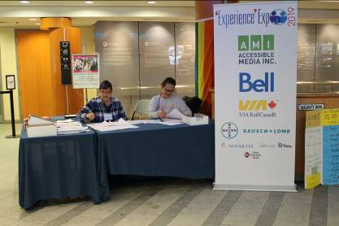
Crowning the ‘Experience’ Expo this year, the CCB hosted the Assistive Technology Forum, an interactive panel discussion on the vital role of assistive technologies in levelling the playing field between those with vision loss and the sighted community, especially with respect to inclusion in the workplace. The panel included Louise Gillis, CCB National President; Jutta Treviranus, Director and Founder of the Inclusive Design Research Centre, Head of the Inclusive Design Institute, and a professor at OCADU; Chelsea Mohler, Assistive Technology Educator and Community Engagement Specialist at BALANCE for Blind Adults; and Albert Ruel, Western Canada Coordinator of the Get Together with Technology program, a CCB collaboration with Kim Kilpatrick which provides training on assistive devices by and for people with vision loss in groups across the country.

Gathering an audience of nearly 100 attendees and stakeholders from across the vision loss community, the panelists delivered their views on the critical importance of creating inclusion through designing universal accessibility, lowering barriers such as the cost of new technologies, and increasing access to adequate technology training, and discussed the vital role we can all play in working together, with government, with business leaders, and with educators to find accessibility solutions. And the audience listened. “You could have heard a pin drop,” observed Michael Baillargeon, CCB Senior Advisor of Government Relations and Special Projects, and the primary organizer and facilitator of the forum. You can listen to a video recording of the panel discussion at www.youtube.com/watch?v=KtQd_CrccO0
To share your personal experiences with accessibility, assistive technology, and employment as a person living with vision loss, you can help the CCB by participating in the forum survey at www.surveymonkey.com/r/accessible-tech

To wrap up the day, the CCB Toronto Visionaries hosted a Community Social, a catered sit-down 3-course dinner with a cash bar, music, and the drawing of a ballot for the Expo’s Grand Prize: a weekend trip for two to Ottawa, including business-class train travel courtesy of VIA Rail Canada and two nights’ accommodation at the Best Western Plus Ottawa Downtown Suites courtesy of Best Western.

With the 2019 WCW ‘Experience’ Expo behind us, what’s in store for next year? White smiles and says, “Just wait and see!”
CCB Toronto Visionaries Chapter
www.ccbtorontovisionaries.ca

CCB Rocks info and upcoming event!++

Hello from CCB Rocks and the Canadian Adaptive Climbing Society,
Thank you for visiting our booth at the WCW Visionaries Experience Expo.

CCB ROCKS is a newly formed group in the process of applying for chapter status with the Canadian Council of the Blind (CCB).

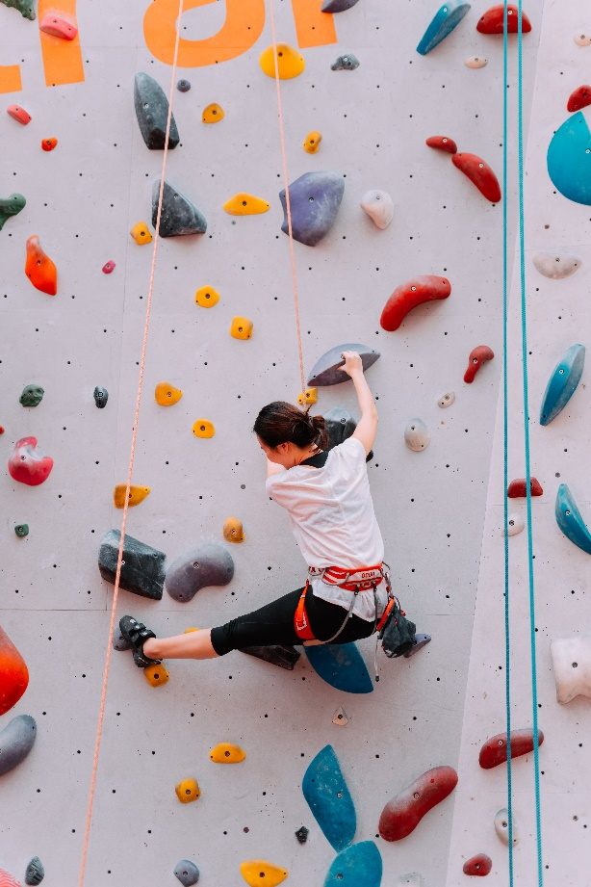
The primary purpose of CCB Rocks is to introduce current & new CCB members to the exciting sport of adaptive indoor & outdoor climbing. This will be done with the guidance of, & in partnership with the Canadian Adaptive Climbing Society.

“I’m just so happy”, Climber Maria Fitton exclaims as she hugs her belayer with tears in her eyes after coming down from her third climb – the first that she made it to the top of. The feelings of challenge, team work, accomplishment and joy were clear across Basecamp Climbing at the first CCB Rocks event. This new club is a chapter of the
Canadian Council of the Blind that helps to introduce and foster the development of members in the sport of rock climbing. Rock climbing is a sport that develops strength, coordination, balance and endurance, all in a very scalable way. Regardless of current fitness or confidence, CCB Rocks members are presented with a challenge appropriate for their current abilities and the opportunity to grow from there. Founding member and president Myra Rodrigues learned to climb at Metcalfe Rock, one of Ontario’s finest climbing areas. Myra came home with a passion to share this sport with her peers, creating opportunities for
participants to find an activity that they can share with family and
friends.

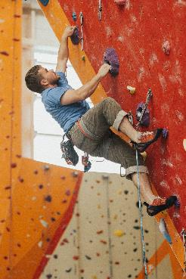
The Canadian Adaptive Climbing Society makes rock climbing accessible for individuals living with sensory & physical barriers. Rock climbing is a sport where the goal is to reach the top of a vertical wall either outside on real rocks or indoors on manufactured hand and foot holds. This is done using a harness and rope that will catch you if you fall and allows you to be lowered gently to the ground once the top is reached. Rock climbing is inherently a very tactile & adaptable sport in that the difficulty can be easily modified and, especially indoors, the holds can be moved changed and added. Regardless of ability when someone starts climbing, they will be able to build skill and get stronger. The Canadian Adaptive Climbing Society uses specialized gear, systems and strategies to accommodate all needs on the wall and aims to create independence. This independence allows participants to share their hobby with friends and family, making climbing a unique adaptive sport.
Lets get climbing!

Please feel free to call either Kate (519 857 3503) or Myra (416 489 9323) to register or for more information.
Submitted by:
Kate Stewart
Director | Canadian Adaptive Climbing Society
Office: +1 (519) 857-3503
kate@canadianadaptiveclimbing.com www.canadianadaptiveclimbing.com

Myra Rodrigues
President, CCB Rocks Chapter
myrarodrigues@rogers.com
Phone: (416) 489-9323

What it’s like to be visually impaired in a world full of people distracted by smartphones ++

I was born with optic atrophy, so I have a very narrow field of vision. I basically just see out of one corner of my left eye. I use a white cane, and when you’re born with this condition, it’s just natural that you learn to walk with a cane and travel quite confidently.
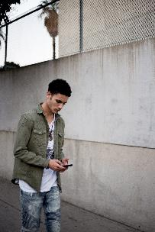
But I’m relying on people to see me. And it doesn’t always happen that way. We think of distracted drivers, but we don’t think of distracted pedestrians and they can be just as dangerous.

Fellow pedestrians who are staring down at their devices, engrossed in a phone call, text or e-mail message have made walking challenging for me. There have been numerous times when people have walked into my path.

Since I use my cane in an arc-like manner, I have inadvertently caused a few distracted pedestrians to stumble, causing them to unleash a string of expletives. On other occasions, after bumping into me, I hear a stammered “sorry” as they sheepishly scurry away. Ironically, others will tell me to watch where I am going. I’m always a little blown away by that.

These kinds of things happen maybe two or three times a week.

I walk along Bank Street, which is one of the main roads here in Ottawa, to and from work. So I have a lot of occasion to walk downtown. I have learned not to walk too close to the edges of the sidewalks, lest I get knocked into traffic. Some pedestrians walk with a device in one hand and hot drink in the other, which can double the danger should they run into me accidentally.

Distracted parents’ children scoot out of their reach, and as my field of vision is narrow, I risk falling over small kids in my blind spot and incurring the wrath of their parents. As many devices are paired with tiny earbuds and microphones, it is almost impossible for me to distinguish whether they are speaking to me or someone else.

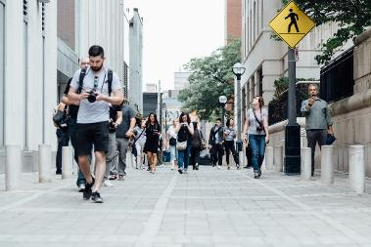
When I’m crossing a street, I’m kind of hoping the other pedestrians will see me, but sometimes they’re on their phones or sending a text or doing what they’re doing. It makes crossing the streets a little bit challenging. But what I do, if they’re available, is use the audible pedestrian signals. You’ve probably heard them. You push the button to activate them, and I find sometimes the sound they make makes everyone pay attention for a while. I tend to use them when they’re available, but they’re not at each corner.

I could go down a real rabbit hole about some people on power wheelchairs. I’ve been knocked over by a couple of those on occasion. I think they think I’m going to see them and jump out of the way. Well, not quite.

I mean, I don’t want to trip anybody, but inevitably, somebody does walk in the path of my cane. You’ll get some interesting reactions. I love when people say, “I didn’t see you.”

Well, you do have to have a good sense of humour.

Shelley Ann Morris lives in Ottawa.
As told to Wency Leung, The Globe and Mail, PUBLISHED FEBRUARY 18, 2019

WBU and ACB Announce Results from the First Worldwide Survey of Audio Description Activity++
A new international survey reveals that audio description (AD) is an important assistive technology worldwide providing access to people who are blind or have low vision to the arts and many other visually-rich events.

The new international AD survey (69 countries and the Pacific Disability Forum) finds that:
- 67% of respondents said that AD is available in the respondent's country;
- cinema, television, live performing arts, and DVDs lead the list of the type of AD experiences available (followed by museums, the web, smartphones, in educational settings and in visitors' centers);
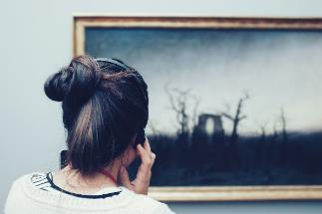
- almost 45% said that AD is required by law (64% of those respondents reported that it was required for broadcast television); and
- 99% of respondents said that they believe AD or more AD should be available.

The World Blind Union and the American Council of the Blind are long-time supporters of the growth of AD. Both groups are eager to learn more about the use of AD by people who are blind or have low vision in its member nations, including some of the barriers to its use. (The World Health Organization reports that an estimated 253 million people live with vision impairment.)

Audio description makes visual information of media and the visual or performing arts, in particular, more accessible to persons who are blind or vision impaired. For media and in the performing arts, language, carefully crafted and timed, is voiced usually during the natural pauses in a program's original soundtrack.

Kim Charlson, President of the American Council of the Blind, emphasizes that "Cultural activities are an important element of our society, often expressing values, trends, fads, historical perspectives, or future directions. People who are blind or visually impaired want and need to be a part of society in all its aspects.
Audio description provides the means for blind or visually impaired people to have full and equal participation in cultural life, accessibility to an event, and the right to be first-class citizens.
In short, the ability to contribute to, participate in, and enjoy the treasures that society offers."

Jose Viera, CEO of the World Blind Union, says that "Throughout the world unemployment among people is a significant problem. I am certain that with more meaningful access to our culture and its resources, people become more informed, more engaged with society and more engaging individuals-thus, more employable."

The full report from this survey is available at:
http://acb.org/adp/docs/WBU-ACB%20%20AD%20Survey-FINAL%20REPORT.pdf
Additional information about ACB's Audio Description Project is available at:
www.acb.org/adp

Important News about CELA's new website++
We have exciting news! In early March 2019 we will be launching a new website platform designed to make it easier and faster for you to access our entire collection. We are combining the CELA and Bookshare collections into a single, mobile responsive, streamlined website so patrons can easily access more than 650,000 titles in a variety of formats.

Our new platform offers:
A clean, simplified website that is easy to navigate. A mobile-responsive interface to make downloading books directly to accessible reading apps faster and easier. Consolidated search records to simplify finding the books you want in the formats you need. A single, streamlined registration process for both CELA and Bookshare. Enhanced privacy and improved protection for copyright laws.
While our website is changing, our commitment to provide our patrons with a comprehensive collection of accessible reading materials and excellent customer service remains unchanged. Services you count on, such as home delivery, single use braille, auto selection of titles, and direct downloads will continue. Our growing collection, plus the Bookshare collection, will be available in the formats of your choice, just as they always have. And we are committed to ensuring your privacy, while also enhancing protections for the materials we produce thanks to the provisions in Canadian Copyright Act.

Things to know about our new website
Our address is not changing. You will still find us at [http://celalibrary.ca]Your login and passwords remain the same for our new website. If you are currently a Bookshare patron, your CELA account will now give you access to all of the CELA and Bookshare materials in one single search through the [http://celalibrary.ca] website. You will no longer need to log in to Bookshare and CELA separately to find your books.

CELA patrons can continue to register for free for the optional Bookshare account to access an additional 550,000 accessible titles. We are migrating all of your account information, including your CELA bookshelf to our new system. Holds placed on materials currently in our collection will also be transferred. Holds on materials that are specified as “on order” in the CELA collection will not transfer to the new system.
Please make note of these titles for your records and request them when they become available. All the reading materials and support services you’ve enjoyed through CELA will continue to be available to you. We are here to help. Our new website will include information to help you navigate. As always, if you have any questions about your CELA account please contact us by email at [help@celalibrary.ca] or by calling our Contact Centre at 1-855-655-2273

Over the coming weeks we will be sharing more information about our new website via our newsletters, and social media. Once the new website is launched, we encourage you to explore it and provide us with your feedback. Our decision to develop this new website was driven by our commitment to provide the best possible experience to public library patrons using CELA services.

We look forward to introducing you to your new website and we thank you for your ongoing support.
Michael Ciccone, Executive Director, Centre for Equitable Library Access

In Memory++

It is with a heavy heart that we’d like to let you know that CCB Hands of Fire chapter lost one of our very first and cherish sculpture members, Carol Mondsier. Carol brought passion, wisdom, and creativity to the room every Saturday. And she will be dearly missed by us all.
Submitted by NOORA MAHMOUD
Secretary/Treasurer
info@handsoffire.org
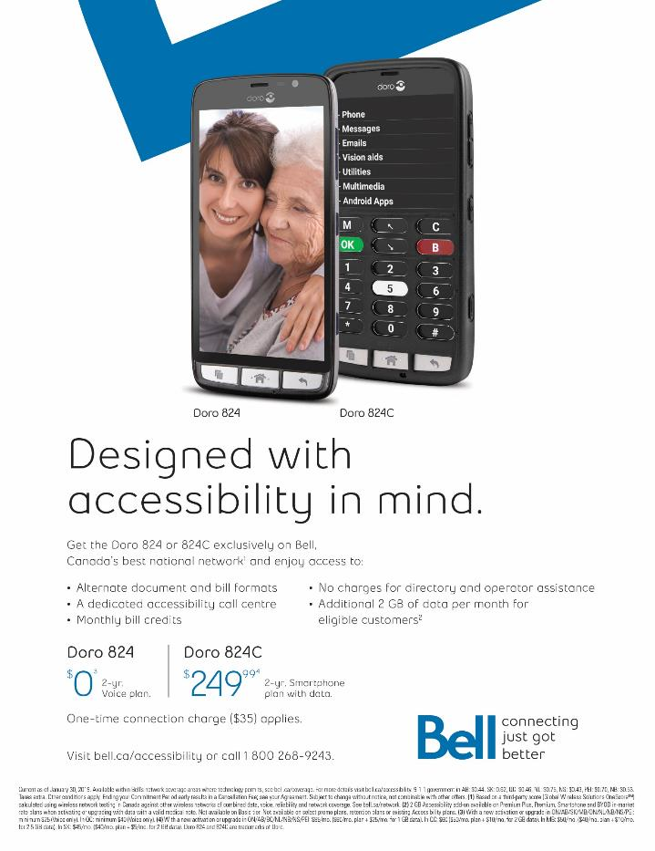

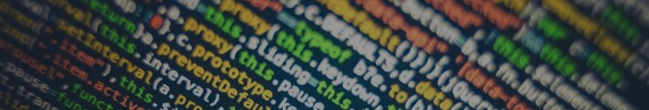
Assistive Technology

A quick primer on how to convert a Facebook photo from your iPhone/iPad containing text so that screen reader users can enjoy the learning/laughter as well++

This primer supposes you are using iOS 12.x.

- download and install the free iOS app called Seeing AI (https://www.collective-evolution.com/2019/02/15/meet-the-kenyan-engineer-who-created-gloves-that-turn-sign-language-into-audible-speech/
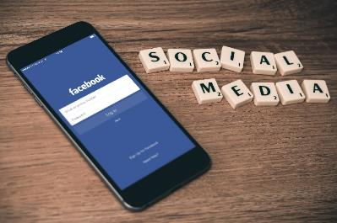
) . It’ll be your conversion tool.
- With focus on the target photo in Facebook one finger double tap to open it.
- Scroll through the page to find the More Button and one finger double tap to reveal a list of options, the first of which will be the Save Button. One finger double tap that button and the photo will be saved to the Camera Roll in your Photos Folder.
- Navigate to your Photos Folder and locate the last photo saved in the Camera Roll and open it with a one finger double tap.
- With the photo opened navigate to the bottom of the page and one finger double tap on the Share Button.
- Scroll through the list to find Seeing AI in the list and one finger double tap to launch it. It will convert the photo and any text therein for you. If the photo contains a picture it will attempt to interpret it, and in another section of the screen it will present the converted text.
- copy the text to the clipboard with a three finger quadruple tap.
* Navigate back to Facebook and locate the photo in question. You may have left it open when you navigated to the Photo Folder, so locate the Close Button and one finger double tap it. Otherwise, scroll to the original photo and perform a two finger double tap and hold to launch the edit field where you will paste the converted text.
- In the active Edit Field you will spin your Rotor to the item called Edit, then swipe up or down with one finger to find the Paste Button and one finger double tap it to paste the text from the clipboard.
- Once the text is pasted you can scroll to, and one finger double tap the Save Button.

Thank you in advance for making the Facebook world a little more accessible and enjoyable for blind, partially sighted and deaf-blind Facebook users.

In the News

Onley's long road to accessibility a lesson for us all++
We all complain, habitually and self-pityingly, about punishing snowfalls.
Especially lately. But for David Onley, the snow banks and other barriers never truly melt away.

For a time, as Ontario's lieutenant-governor, the obstacles were magically cleared away. Enveloped by an entourage, cocooned by bodyguards, he surmounted the roadblocks.

An elevator was installed in the vice-regal suite at Queen's Park, and a ramp was retrofitted in front of the legislature. Thanks to the superhuman powers emanating from the Crown - which he embodied from 2007-14 - Onley not only made his way, but also paved the way for other wheelchair-bound Ontarians.
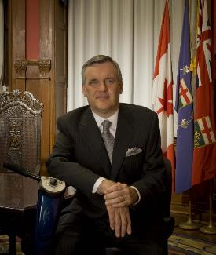
Ensconced in his scooter, chauffeured in a specially outfitted van, backed by his band of official enablers, his disability - or inaccessibility - seemingly diminished. But after a lifetime spent grappling with the fallout from a childhood bout of polio, Onley always knew it was only a matter of time before he was on his own again.

Now, Onley no longer speaks for the Crown. But he still has a voice.
He is using it to describe what he sees at ground level - and getting a hearing from the powers above. Appointed last year by Queen's Park to conduct a formal review of accessibility in Ontario, he has just submitted his findings to the Progressive Conservative government.

There is still a stunning disconnect for the disabled, and a growing gap in how the able-bodied perceive the reality of inaccessibility.

Onley wouldn't tip his hand about the details of his report, which will be shared with the public later. But he didn't disguise his disappointment.

"We still have a very inaccessible society, a built environment that is very inaccessible," he told me. "The people who believe it's accessible are members of the able-bodied population."

A longtime believer in the original legislation, which passed with all-party support, he now fears that its 2025 target for full accessibility will go unfulfilled.

Onley points a finger not only at politicians but bureaucrats, architects, developers, administrators and inspectors who fail to do their duty to the disabled.
And all of us. For the disabled are us, sooner or later.

The older we get - and our population is aging fast - the more likely we are to find ourselves in their shoes: First with canes, then walkers, then wheelchairs.

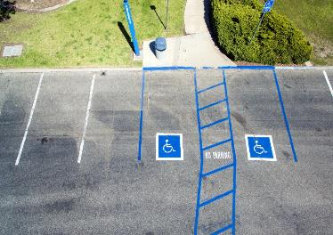
Eligible, ultimately, for those special parking permits in our windshields that confer priority access to reserved spots. Paradoxically, the advent of priority parking has helped to distort the reality of disability today in Ontario.

Those signs are ubiquitous, serving as a symbol of access and open doors.
But the typical reserved parking spot is a dead end - leading only to barriers that leave the disabled out in the cold at most malls and public buildings.

"It's shocking the number of places that are fully inaccessible and yet out front, you'll see a wheelchair sign," he said. "It depends on how angry you want to be."

The problem isn't just the false signal it sends to the disabled on the spot, but the facade it conveys to society at large that access is everywhere.

Onley is especially vexed by the lack of foresight from the self-styled visionaries who make up the architectural community. He points to new buildings that win architectural awards but get a failing grade for accessibility, which should surely disqualify them from recognition.

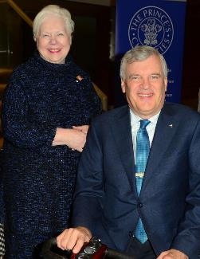
Over the years, I had watched Onley's handlers help him navigate unforeseen obstacles and predictable impediments. This week, I watched him flying solo again, when he wended his way to a Ryerson University democracy forum I hosted for Onley and his successor as lieutenant-governor, Elizabeth Dowdeswell: A Conversation with the Crown.

Without government officials to smooth the way, it fell to Ryerson organizers to ensure that he didn't stumble on his journey. In preparation, Onley patiently walked me through his detailed checklist to overcome any obstacles.
2 Lieutenant-Governor Elizabeth Dowdeswell and David Onley

Yes, they had a ramp leading onto the stage, but had they verified its dimensions to ensure his scooter could mount the slope? Was the platform wide enough for him to pre-position without toppling over? Any stairs along the way leading to the campus venue?

Where was the nearest parking? Was it underground or at least sheltered? Was there an underground passageway leading to the event? If not (and there wasn't), what about the weather? Who would shovel any snow in the way?

Presciently, as it turns out, Onley reminded me of the perils of ice and snow for someone in a scooter. Even a few centimeters can gum up his wheels, and a serious snow bank is a dead end.

Even before Toronto's unexpected 20-centimetre snowfall that came after our chat, Onley had confided that he typically refuses all winter speaking engagements - too unpredictable and insurmountable. But he was making a rare exception to be with his successor, Dowdeswell.

Practiced in both logistics and logic, Onley made it onstage without a hitch, and expounded on vice-regal arcana without a verbal stumble.

While it's always an education hearing him talk about the abstractions of our constitution, he also delivers enduring lessons on the reality of inaccessibility.
By Martin Regg Cohn
The Toronto Star, February 9, 2019

Gene therapy first to 'halt' most common cause of blindness++
A woman from Oxford has become the first person in the world to have gene therapy to try to halt the most common form of blindness in the Western world.

Surgeons injected a synthetic gene into the back of Janet Osborne's eye in a bid to prevent more cells from dying. It is the first treatment to target the underlying genetic cause of age-related macular degeneration (AMD).

About 600,000 people in the UK are affected by AMD, of whom 350,000 are severely sight impaired. Janet Osborne told BBC News: "I find it difficult to recognize faces with my left eye because my central vision is blurred - and if this treatment could stop that getting worse, it would be amazing."

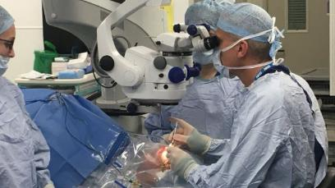
The treatment was carried out under local anesthetic last month at Oxford Eye Hospital by Robert MacLaren, professor of ophthalmology at the University of Oxford.
4 Prof Robert MacLaren inserting gene therapy into Jane Osborne's left eye (Picture from BBC website, taken by Fergus Walsh)

He told BBC News: "A genetic treatment administered early on to preserve vision in patients who would otherwise lose their sight would be a tremendous breakthrough in ophthalmology and certainly something I hope to see in the near future."

Mrs Osborne, 80, is the first of 10 patients with AMD taking part in a trial of the gene therapy treatment, manufactured by Gyroscope Therapeutics, funded by Syncona, the Wellcome Trust founded investment firm.

What is AMD?
The macula is part of the retina and responsible for central vision and fine detail. In age-related macular degeneration, the retinal cells die and are not renewed. The risk of getting AMD increases with age.

Most of those affected, including all those on this trial, have what is known as dry AMD, where the decline in sight is gradual and can take many years.

Wet AMD can develop suddenly and lead to rapid vision loss but can be treated if caught quickly.

How does gene therapy work?
As some people age, genes responsible for the eye's natural defenses start to malfunction and begin destroying cells in the macula, leading to vision loss.

An injection is made at the back of the eye, which delivers a harmless virus containing a synthetic gene. The virus infects the retinal cells and releases the gene. This enables the eye to make a protein designed to stop cells from dying and so keep the macula healthy.

The early stage trial, at Oxford Eye Hospital, is primarily designed to check the safety of the procedure and is being carried out in patients who have already lost some vision. If successful, the aim would be to treat patients before they have lost any sight, in a bid to halt AMD in its tracks. That would have major implications for patients' quality of life.

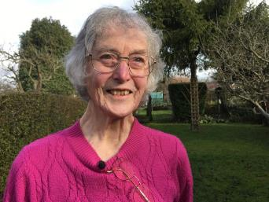
It is too early to know if Mrs Osborne's sight loss in her left eye has been halted but all those on the trial will have their vision monitored. Speaking at home, she told BBC News: "I still enjoy gardening with my husband, Nick, who grows a lot of vegetables.

"If I can keep peeling and cutting the veg, and retain my current level of independence, it would be absolutely wonderful."
5 Janet Osborne hopes to continue gardening if her sight loss is halted (Picture from BBC website, taken by Fergus Walsh)

There is already a successful gene therapy treatment for another rare eye disorder. In 2016, the same team in Oxford showed that a single injection could improve the vision of patients with choroideremia, who would otherwise have gone blind. And, last year, doctors at Moorfield’s Eye Hospital, in London, restored the sight of two patients with AMD by implanting a patch of stem cells over the damaged area at the back of the eye.

It is hoped that stem cell therapy could help many people who have already lost their sight. But the Oxford trial is different because it aims to tackle the underlying genetic cause of AMD and might be effective in stopping the disease before people go blind.
By Fergus Walsh

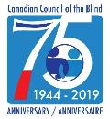
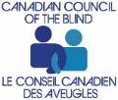
www.ccbnational.net
ccb@ccbnational.net
1-877-304-0968

