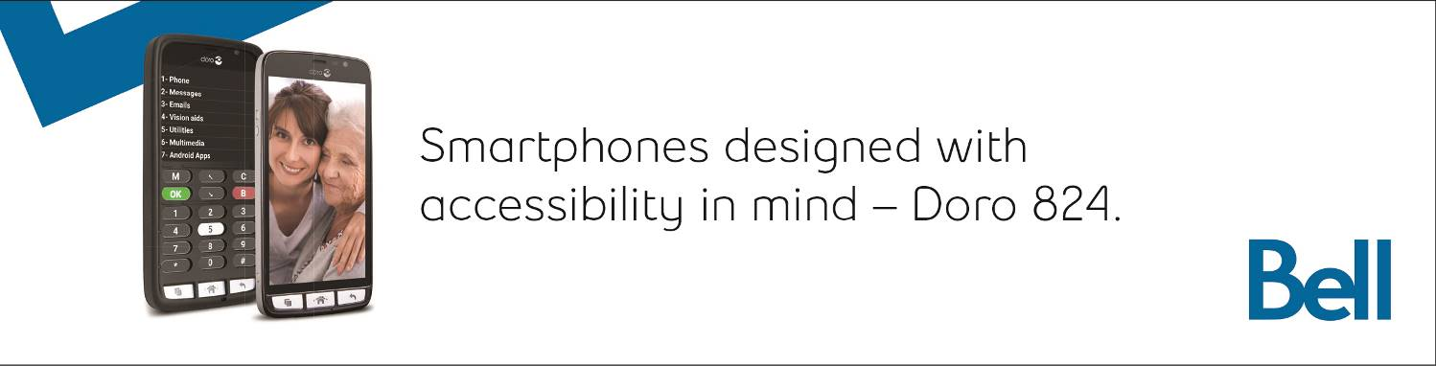

VISIONS

Canadian Council of the Blind

Newsletter

April 2019

“A lack of sight is

not a lack of vision”

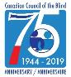

President’s Message++
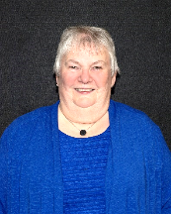
As we March into spring, weather is improving and everyone is becoming more active. We continue to be active at the National level on working toward great access medications and health care by proving input to companies and Government at all levels. As new medications become available or are in the very preliminary stages, we along with other organizations, are providing information regarding accessibility concerns that many of us have to try to avoid as many issues as possible by the time they reach end users.
1 Louise Gillis - National President

Several groups have been busy preparing submissions to Canada Transport Agency and the CRTC regarding their proposed regulations prior to these regulations moving to Government for final approval. The regulations along with the Accessible Canada Act are not perfect but at this stage it is very important to have them passed in legislation before the summer recess. Once in place they will provide greater accessibility to all federally run jurisdictions. They will come up for review in five years which gives more time for organizations to provide recommendations for change where needed. The submissions take a great deal of time and work, by all the committees, for which I thank everyone involved for their hard work and dedication.

Also, I wish to thank the over 450 people who responded to the technology survey which was completed and now is being compiled. This has given a lot of valuable information, which will be submitted to government, and will be very useful toward the hiring of persons with sight loss by government in their budget promise of 5000 persons with disabilities over the next five years.

CCB’s other committees such as By Laws, Membership and Advocacy continue to meet on a regular basis on their differing agendas. Other groups that have met over the month of March are World Blind Union (WBU),, Consumer Access Group (CAG), Barrier Free Canada (BFC), and Braille Literacy Canada (BLC) for which we have representation.

Check the website for these groups for their latest updates. { WBU - CAG - www.cag-tccdv.ca/ all position papers are on the site. WBU http://www.worldblindunion.org. The World Blind Union (WBU) is the global organization representing the estimated 253 million people worldwide who are blind or partially sighted. Members are organizations of and for the blind in 190 countries, as well as international organizations working in the field of vision impairment. BFC - http://barrierfreecanada.org/. Barrier-Free Canada/Canada Sans Barriers (BFC/CSB) advocates for the Canadian Parliament to enact a strong and effective Canadians with Disabilities Act (CDA) to achieve a barrier-free Canada for all persons with disabilities. BLC - www.brailleliteracycanada.ca/ BLC is a not-for-profit corporation committed to braille promotion and the right of braille users to equal access to printed information.}

Check out GTT & CCB Health and Fitness for the latest news items through Facebook, blog and twitter. There are lots of helpful hints, tips and ideas there for many of our individual needs. Now that curling is over watch for news on the Atlantic Sports & Recreation Weekend coming up in May.

It is important for members to keep active in whatever way they can at local, divisional and national levels. That can be by going to socials, sports & recreational activities, advocacy, membership development, mentoring, or taking a leadership role. Everyone counts no matter the level of ability. Enjoy Visions and send in any interesting items you may taking place in your community.
Louise Gillis, National President

Announcements

Thank You Volunteers++
In Celebration of National Volunteer Week
Canada is a nation where volunteering is a mainstay. According to Volunteer Canada’s website, 12.7 million volunteers currently give of their time, energy, skills and experience.
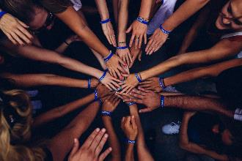
National Volunteer Week takes place from April 7-13 this year. There is no better time to thank the many volunteers that contribute to CCB’s success. We have recently marked out 75th Anniversary; we know that volunteer power played an important role in helping our organization to reach that milestone.

Volunteers fulfill a wide variety of positions nation-wide within the 80+ chapters throughout Canada. Leadership roles, such as President, Treasurer and secretary are occupied by volunteers.

Each chapter allows for a certain percentage of volunteers with vision to help with some administrative tasks. At the national level, volunteers serve on CCB’s Board of Directors. Chapter volunteers also staff display booths, assist with special events and provide help and support during programs and activities.

Peers volunteer to teach peers through the Get Together with Technology (GTT) program. Volunteer guides guide and assist those involved in sports programs. Sighted volunteers provide some help with Book Clubs.
Volunteers also serve on various committees both within CCB as well as in the community at large. Their tireless efforts are helping to break down barriers and create a more inclusive Canada. Advocacy, pharmacare, transportation and telecommunications groups have become more aware of the requirements of those living with vision loss thanks largely to the input from those who give of their time and experience.
Volunteers also contribute to our monthly Visions newsletter.
It is said that one of the prime reasons that people choose to volunteer is having been deeply and personally affected by a cause or situation. In many instances, those who have directly or indirectly experience vision loss have chosen to take what they have learned and experienced to bring about positive changes for themselves and others. With the trend toward short-term, episodic volunteering, it is worth noting that many of CCB’s volunteers have been involved with CCB for many years.

Those in the blind/low vision community and beyond would like to take this opportunity to thank all of the volunteers involved with the Canadian Council of the Blind. During National Volunteer Week and throughout the year, please take the time to thank the volunteers for their continued enthusiastic support for CCB.

Peterborough Woman Wins Medal for Making Angels for Service Personnel++

In mid-January of this year, Suzanne Thomas, formerly a CCB member in Toronto, now living in Peterborough, was struck speechless when she received a medal from Chief of Defense General Jonathan Vance for the angels she provides for service personnel around the world.

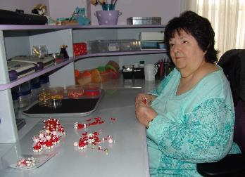
A highlight of Suzanne’s involvement with CCB in Toronto was when she took on Howard Moscoe, who was not only a city councilor at the time, but also chair of the board of the Toronto Transit Commission. In that position, Moscoe encountered a good deal of opposition from blind or partially sighted patrons who were bounced off the Wheeltrans program because they didn’t use wheelchairs. CNIB didn’t take up the cause, but CCB Toronto, led by Suzanne, gave voice to the issues, and was successful in getting many of the patrons back on the program. Now, the Thomases daughter, Debora is a vice-president of CCB Peterborough chapter.
2 Suzanne Thomas working at her craft table

“I was blown away,” Suzanne said in a recent interview about the medal for CCB Peterborough chapter’s weekly radio show, Insight Peterborough. “General Vance says that they love these angels that come in the Christmas boxes that go all over the world. They’ve got them hanging on their shaving mirrors, on their key rings, on the ceiling of their little huts, on their night tables, and on their filing cabinets.”

Suzanne has received many E-mails from the people who have received her angels.

“Some of them are very sad, some of them are funny,” she recalled. “There was a young fellow, and he was 20 years old. He said: ‘I hope you’re not offended, but I have a bomb-sniffing dog. She goes first, so I put my angel on her harness so that if she dies, I want to have the angel go with her.’”

In the past “ten years plus,” Suzanne has made 40,000 angels.

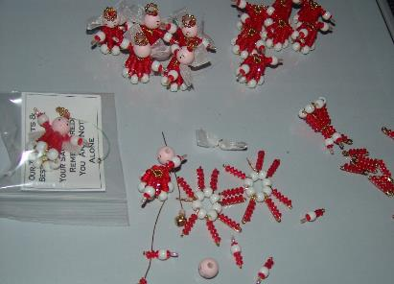
“The only thing that slowed me down was that I got sick, and had to spend a lot of time in bed,” Suzanne recalled. “I’m kind of panicking, because I want all my kids to get an angel. You see, when you’re 74, you can call all these people your kids. I have to have the boxes ready by September 1 so that they can go down to Nova Scotia. They may put them on a frigate,” Suzanne continued, and then I’ve got angels in the helicopters, the American helicopters, and the big airplane that sends supplies over to the countries that they’re going to, and it’s army, navy, air force, and military police. They all get these angels, and so do the heads of staff.
3 A close up of Suzanne's beads.
Suzanne explained that the angels are made with seven safety pins, each containing five beads, a bit of wire, and a bow which serves as the wings. The halo is made of much smaller beads.

Suzanne said that she has no idea when her medal actually arrived at her house.

“It was in the mail during the strike, and then the mailbox froze, so I don’t know how long it was in there before we got it, but it was a lovely surprise.”
By Devon Wilkins.

The Canadian Blind Chess Association and the 2019 Quebec City tournament++

Are you an avid chess player living in Canada?

Or maybe you are an aspiring one who is looking for ways to play chess and have some fun while at the same time make new chess friends?

Then the Canadian Blind Chess Association may be what you are looking for.

Why not become a member and join our group!

Come on in and let's play chess together!

We want to invite you to register for the Quebec chess tournament to be held in April.

It's opened to everyone!

For more info on the annual Quebec chess tournament please go to this link https://www.dropbox.com/sh/zcji13ezaskeepa/AACsNyfRJWHOtIxw25Vz5xIia?dl=0

Gor more information about the Quebec City tournament and to look for the Canadian Blind Chess Association on Facebook, contact Rebecca at
amrywoddyddiauheulog@gmail.com
or at cqpa@bellnet.ca
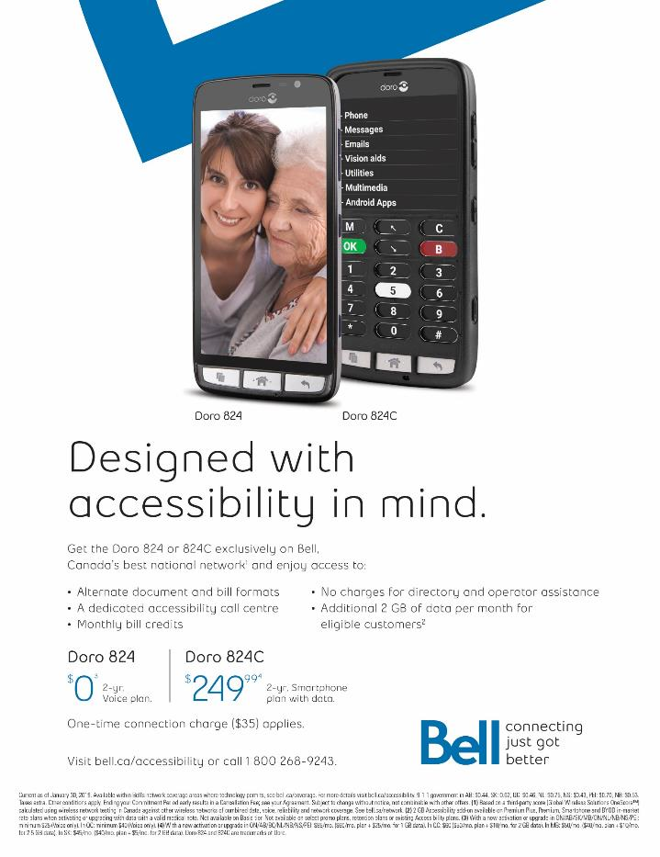

Assistive Technology

Get Together with Technology (GTT) at CSUN, March 13 to 15, 2019++

Thanks to Markido Inc. of Ottawa
(https://markido.com/try?utm_source=markido.com&utm_content=try-topnav ), four CCB staff and volunteers had the great good fortune to attend the 34th CSUN Conference in Anaheim California.

Visit the GTT network for reports from Kim Kilpatrick, Rebecca Jackson, Maryse Glaude- Beaulieu and Albert Ruel.

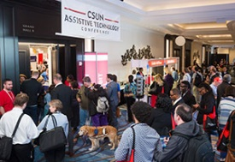
Sam Burns, CEO of Markido Inc. promoted their PowerPoint Plug-in, “Engage” during CSUN and you can get a peak at its great support for accessible presentations by activating the below links.
You can download your own free version and see how it will help you get access to all the information in the PowerPoint presentations you receive, and to create your own accessible presentations for circulation.
4 People entering the conference (photo from www.csun.edu)

One of the exciting products produced by Markido is Engage.
( https://markido.com/about )

Engage is a PowerPoint add-in that lets people of any skill-level create visually impressive presentations. Engage comes with thousands of design assets that are easy to incorporate into any presentation using drag and drop functionality. Users can also create and edit infographics and data maps right in PowerPoint.

Make your presentations more accessible for people with disabilities.
( https://markido.com/engage )

Run our accessibility tests to get an overview of how accessible your presentation is.

-We provide quick and convenient shortcuts to fix the issues that are found.
-Visually check and fix the screen reading order of your slides without having to use the selection pane.
-Add a slide description so users with screen readers can get an overview of what the slide is about before reading the detailed content.

Over 100,000 amazing presentations have been created with Engage.

Get a free trial version of Engage. (https://markido.com/try?utm_source=markido.com&utm_content=try-topnav )

Donna's Low Tech Tips, Pen Friend++

Meet the Pen Friend. If you have not already been introduced to this nifty little gadget then here is your opportunity. Meet this very affordable and very useful little gadget. It was developed by the RNIB of Britain.

Yes, it is shaped like a large pen and has a very nice speaker that enables you to hear what you are doing. The Pen Friend enables you to label things using specially adapted tiny labels. The instructions can be accessed on the card that it comes with; a really nifty way to produce instructions. This is how it works.

- When you turn on your Pen Friend you hear some very delightful sounds and then you know that Pen Friend is ready to go to work.
- Place Pen Friend on one of those special labels that comes with your Pen Friend then press the record button.
- Give a short audio description of what you want the label to describe.
- Press a button to end the recording.
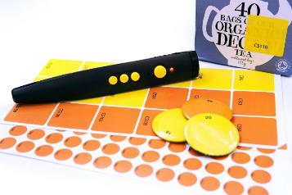
- Now you are ready to complete the task by taking your label and placing it on wherever you want it to be. Can, tin, box, file folder, whatever.
- You can go back to what you have just labeled and using your Pen Friend you can tell what you have just done.
- Turn on Pen Friend and voila! With the press of a button Pen Friend will tell you what your label says; what you have just recorded in your own voice.

This is indeed a neat little gadget and is extremely affordable. You can find this gadget at such places as http://www.maxiaids.com and http://www.independentlivingaids.com So go out there and make friends with the Pen Friend. To contact me, send me an email at info@sterlingcreations.ca

In the News

Lynda Todd with art displayed, "Rites of Passage” series, at Cavan Art Gallery, Cavan, Ontario++

Visually impaired artist paints her mark in galleries!

Lynda Todd was born into a family of artists, so she naturally had an affinity for creative expression. However, she never took herself seriously as an artist. Why not? Lynda was born legally blind and much of her remaining vision is colour blind.

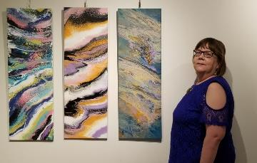
In spite of this challenge, Valerie Kent, Director of Cavan Art Gallery, encouraged Lynda to take lessons and she started acrylic abstract painting. Her desire to explore and express creativity have resulted in unique colour choices melded with interesting use of texture. This particular medium has evoked an intense desire to communicate and express herself to the visual world.
5 Lynda Todd with “Rites of Passage” series at Cavan Art Gallery

Valerie was able to ascertain early on Lynda, "was painting from the heart."

“I am blown away with the interest and enthusiasm that my work has garnered. Commissions and sales starting occurring immediately. Then I received multiple gallery acceptances. I would never have thought I would find my happy place in a paint studio!” stated Lynda

She describes her visual disability as an “inconvenience”. Lynda is active in her community striving to bring awareness to those living with inconveniences and provide education and understanding to create a more inclusive and kind community.

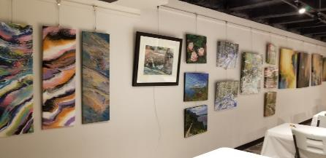
She believes anyone facing a challenge can achieve whatever they want to. Sometimes modifications may need to be made to make that happen. Everything is possible. Including a blind woman creating visual, expressive and beautiful art.
6 Lynda's art in the Cavan Gallery

Moving from a small town Lynda had no idea how much her life would expand with so many more opportunities living in the city of Peterborough, Ontario. She has embraced her "inconvenience" and speaks about it openly providing education and awareness through motivational speaking.

One opportunity keeps leading to another. So many doors have opened now that she has the independence to get around herself and embrace city life.
Lynda is a wife, mother, artist, motivational speaker and adrenaline junkie who enjoys axe throwing, tandem bike riding, and pistol shooting.

Her art has been accepted in three galleries plus a solo show:
- Paul's Art & Frame Gallery, Peterborough
- Solo feature artist for the month of June.
- Gala opening will be June 1st.
- Spirit of the Hills Art Association Show and Sale, Warkworth April - September
- Miskwaa Gallery, July - August
- Cavan Art Gallery- ongoing
Check out her website at www.lyndatodd.com

Get Free On-Demand Verbal Descriptions of Museums ++
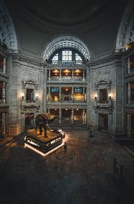
Starting this spring, Smithsonian visitors who are blind or have low vision can access a groundbreaking technology that uses their smartphone cameras or special glasses to get free on-demand verbal descriptions of everything from individual objects to entire exhibitions from sighted agents. The Aira technology is available at all Smithsonian museums in Washington, D.C., and the National Zoo. The new service is provided by Access Smithsonian, which oversees accessibility and inclusion activities for Smithsonian visitors.

“For far too long, museum visitors with vision loss have depended on accompanying friends and family to help them navigate around museums,” said Beth Ziebarth, director of Access Smithsonian. “Now, with the touch of a button, visitors have instant access that not only helps them engage with the museum but also increases their mobility and independence. In the words of one recent user, ‘This revolutionizes the way people with vision loss experience museums.’”

Visitors can access Aira in two ways: by downloading the app to their iPhone or Android smartphone or by using their personal Aira smart glasses—at no cost to the user. In both cases, through artificial intelligence and augmented reality, visitors will be connected to highly trained sighted live agents who can see from their remote location what is in front of or near the user. The agent then helps the visitor navigate the museum.
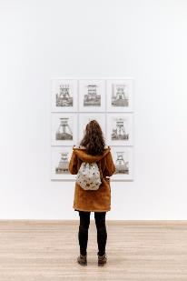
For instance, in the National Museum of American History, live agents can guide visitors to specific objects, such as the Ruby Slippers; specific exhibitions, such as “The First Ladies” and the Star-Spangled Banner Gallery; as well as restrooms, cafés and museum stores. Ongoing services and materials for visitors who are blind or have low vision will continue to be available, including Braille and large-print brochures and docent-led verbal-description tours. In addition, talking tactile floor plans will soon be installed in the National Museum of American History.

About Access Smithsonian
Established in 1991, Access Smithsonian believes the Smithsonian’s exhibitions, programming and content should be inclusive, integrated, independent and dignified. The office is charged with ensuring that all visitors, including people with disabilities, are able to benefit from and have access to what the Smithsonian offers in its buildings, collections and programs. Through collaborations with Smithsonian museums, Access Smithsonian improves access to existing resources and helps design new programs, exhibits and buildings that are accessible to all. Signature programs include Morning at the Museum, designed for youth with sensory-processing disorders and other brain-based disabilities; See Me, for people with Alzheimer’s and their caregivers; and Project SEARCH, a 10-month internship-to-job training program for young adults with intellectual disabilities. For information, visit www.si.edu/visit/VisitorsWithDisabilities.

About Aira
AI stands for Artificial Intelligence; RA stands for Remote Assistance. When you put them together, you get Aira. Aira is a service that connects people who are blind or have low vision to highly trained, remotely located agents.

At the touch of a button, Aira delivers instant access to information, enhancing everyday efficiency, engagement and independence.

Breaking barriers: accessibility at home a costly process++
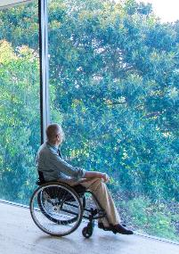
It’s just a few centimeters high, but the sill of the sliding glass door that leads to the back deck of her Barrhaven home is a mountain to Jennifer Glanz.

“It’s little, but I can’t get over it,” said Glanz, who has multiple sclerosis and uses a wheelchair. Glanz and her husband, Eli, have already installed a $4,000 electric lift in their garage so that Jennifer can get out of the house, and recently completed a renovation to make their bathroom barrier free.

They moved with their daughter Emelia, to a bungalow a few years ago when Jennifer’s deteriorating condition made it impossible for her to manage the stairs in their former two-storey home. The small ramp over the door sill is the next item on their reno list for summer — “if we ever get a summer,” Jennifer jokes.

“It’s the next project. And a ramp down to the grass. Emilia will be playing on the grass this summer and it would be nice to be there with her.”

Whether it’s a senior who wants to age in place in her own home, a person battling a debilitating illness, or someone injured in a sudden, catastrophic tragedy like the Westboro OC Transpo bus crash, those facing disability find that barriers abound in the home. In fact, 22 per cent of Canadians live with some sort of physical disability, according to Statistics Canada.

“The older you get, the more likely you are to have a disability,” says Patrick Curran, national executive director of Independent Living Canada, a national non-profit agency that advocates for those living with disabilities and promotes independent living.

“And if you live long enough, you will have a disability.”

Many of the modifications needed to make a home accessible are obvious: a wheelchair ramp to the front door, for example. Others aren’t so apparent.

“One item that’s really big, especially for someone with head injuries, is lighting,” said Sean MacGinnis, co-founder BuildAble, an Ottawa company that specializes in building and renovating homes for accessibility. “You want lighting that won’t put a strain on your eyes. Or if it’s for someone who has a visual impairment, better lighting will eliminate shadows and help them see any changes in elevation in their home.”

MacGinnis founded BuildAble five years ago with partner Kyla Cullain, a registered nurse. The company works closely with their clients’ medical teams -their family doctor or occupational therapist, for example — to develop an appropriate construction plan, he said.

“We started the company out focusing on people who are aging in place, but we’ve found the majority of our clients are people who have had a medical crisis, MS or a stroke or something like that … and we do have a lot of people who’ve been in vehicle accidents too. They’re in mid-life and they want to stay in their homes or they have family that they don’t want to move.”

For Eli and Jennifer Glanz, that meant redoing their bathroom to make it accessible. BuildAble installed a barrier free bathroom that Jennifer can roll up to and swing herself into a spare wheelchair that stays in the shower. The tile floor slopes gently to a drain and a waterproof barrier under the entire bathroom floor means spills or floods cause no damage.
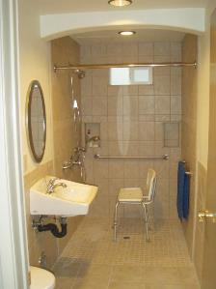
The old sink and vanity was replaced with a “floating sink” that lets Jennifer wheel up to it like a desk. Three heavy-duty handrails give support and stability at the toilet.

“For the longest time we had a standard tub and shower that you see in most showers. Jennifer can’t transfer herself into a standard tub, even if there’s a shower seat. It would be me physically lifting her up and into the tub. That was hard for both of us,” Eli said.

“She keeps reminding me, I only have one back.”

“It brought more independence to me,” Jennifer said. “Before, I would have to have him home and helping me have a shower. Now I don’t. He doesn’t know how many times I shower.”

It cost $15,000 to renovate the bathroom, about 80 per cent of which was paid for with grants from March of Dimes. The family had to cover the cost of the garage lift on their own.

Another clever addition are offset hinges that allow doors to swing completely out of the way, adding a crucial extra five centimeters width to the doorway for Jennifer’s chair to pass.

The simplest and most common modification to a home is to add grab bars and handrails, MacGinnis said, including railings on both sides of a staircase. In the kitchen, countertops and cabinets can be made to lower to wheelchair level, while full-extension drawers are easier to access without awkward reaching.

One of BuildAble’s biggest jobs was to add a full elevator to a home for a man with Parkinson’s Disease, he said.

The cost can vary widely. The cost of home modifications are often included in the insurance payout for accident victims or — as in the case of an Ottawa Public servant who is suing the city for $6.3 million for injuries in the Westboro bus crash — part of the lawsuit claim. Others are helped with the cost through grants from the March of Dimes and other charities or through tax breaks.

“There’s a lot of low-cost things we can do that have a high impact,” MacGinnis said. A grab bar might cost $100. A second staircase railing $1,000. A wooden ramp to the door can range from $500 to $5,000, while a more aesthetically pleasing ramp of interlocking brick could cost $15,000 to $20,000.

A barrier-free bathroom costs between $12,000 and $15,000 while a full reno to make a kitchen full accessible can run up to $30,000, he said.

In Ontario, someone who has suffered catastrophic injuries in a car crash is eligible for $1 million in under the province’s the province’s Statutory Accident Benefit Schedule. But for non-catastrophic injuries, that benefit is capped at $65,000 and will only last five years, said lawyer Najma Rashid, a partner in Howard Yegendorf & Associates.

“Just because someone’s injuries aren’t catastrophic, doesn’t mean they’re not serious,” Rashid said. “Many people with serious injuries might be stuck with that $65,000 and it’s only available for five years so they have to make a judgment call as to whether they’re going to use part of the money for changes to their home or for ongoing treatment needs.”
Additional costs could become part of a lawsuit claim, she said. Lawyers would work with their client’s medical team or hire an occupational therapist or consultant to determine what renovations are needed and their cost.

“And if they do claim it in a lawsuit, they have to wait for that lawsuit to be over. Or self-fund it and look for a reimbursement, but most people don’t have the money to pay for it themselves.”

Those looking for more information on improving accessibility will be able to find it Independent Living Canada’s AccessABLE Technology Expo on May 30 at the Ottawa Conference and Events Centre on Coventry Road. The one-day expo will bring together 20 exhibitors with a broad range of products for disabilities such as visual or hearing loss, cognitive impairment and mental issues. Admission is free, Curran said.

“We’re doing this to build awareness for Independent Living Canada,” Curran said. “But we also want to give to hope to people who have disabilities — to show them that there are people out there doing research and introducing new products that will be of interest to them.”
For more information, visit www.ilcanada.ca
By Blair Crawford
www.ccbnational.net
ccb@ccbnational.net
1-877-304-0968

