VISIONS

Canadian Council of the Blind

Newsletter

May 2019

“A lack of sight is

not a lack of vision”

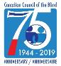
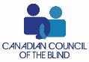

President’s Message++
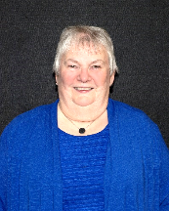
April showers bring May flowers. Many areas have received a lot of rain and flooding in April. I hope all members have not had any major problems with flooding.

Via teleconference I joined Best Medicines Coalition (BMC) to welcome the Advisory Council on the Implementation of National Pharmacare's Interim Report, and is in full agreement that the current system is inadequate to meet the needs of Canadians. BMC has called for significant reforms to address inequities and inadequacies that lead to compromised care and poor outcomes at great cost to individuals and families. The coalition and its members were active participants in the Advisory Council's consultation process. The coalition's submission called for a phased approach to reform, urging leaders to prioritize the most critical disparities and inequities in the system.
1 Louise Gillis - National President

In March Budget 2019 came down and one point of interest was: “To support the independence of persons with disabilities, Budget 2019 also proposes to invest $0.5 million in 2019-2020 towards finding ways to improve the accessibility of electronic payment terminals to enable persons with disabilities to conduct daily activities, such as paying for their groceries, without relying on others”. On this item the committee working on Point of Sale devices for the past year or so have reconvened with a teleconference and again will be working together to work through finding ways to improve accessibility. The committee is comprised of Neil Squires Society, CNIB and CCB. I will keep you updated on this project.
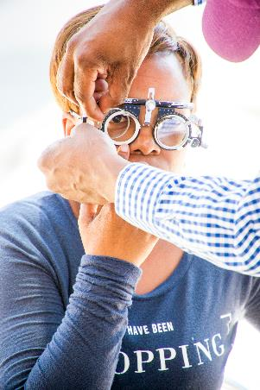
This month CCB was again represented at Canadian Agency on Drugs & Therapeutic in Healthcare (CADTH). This is the place where we work towards eye care medications and treatments in prevention of blindness.
Also in April we held teleconference Board meeting regarding plans for the upcoming AGM on June 26th. Notice will be forth coming.

April ended with a meeting that I attended in Ottawa as a WBU delegate to take part in a Global Action On Disability Network Meeting: Aim of meeting: To further develop our shared commitment to disability inclusive
development and humanitarian action in line with the UN CRPD and to support implementation and our accountability of disability inclusive commitments, in particular through meaningful engagement with Organizations of Persons with Disabilities. This meeting was by invitation from Global Affairs Canada with reports coming out later.

As you can well see lots of things are happening along with all the regular programing and local events.

Louise Gillis, National President

Announcements

You’re Invited: National Tele Town Hall on Accessibility and Inclusion during the 2019 Canadian Federal Election++

The Canadian Council of the Blind and Sterling Creations in collaboration with Elections Canada are pleased to invite you to join our country wide tele town hall to be hosted on Thursday June 06 2019 via Zoom Conference. To RSVP your attendance please email the Canadian Accessible Elections Town Hall Committee at CAET2019@Gmail.com
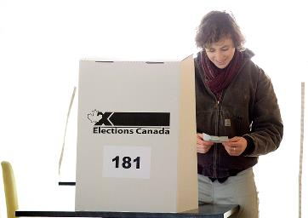
Presenting on behalf of Elections Canada will be Susan Torosian. She will provide an outline of the accessibility features Canadians can expect to experience during the 2019 Federal election, including services available to electors who are blind, deaf-blind and partially sighted. She will also be open to your questions about how the services that will be offered for the election can meet your accessibility and information needs.

Date: June 06, 2019
Times: 3:00 pm Pacific, 4:00 pm Mountain, 5:00 pm Central, 6:00 pm Eastern, 7:00 pm Atlantic, 7:30 pm in Newfoundland

This meeting will last no longer than two hours.

We believe that our tele town hall will assist greatly to help you prepare for the forthcoming Federal Elections to be held on October 14 2019.

About Susan Torosian:
Susan is the Executive Director, Policy and Public Affairs – Regulatory and Public Affairs

Susan Torosian joined Elections Canada in 2007.
Sue holds a Bachelor of Commerce (Business Administration) from the Memorial University of Newfoundland. She joined the public service in 2002 as Director, Communications and Outreach for the Canada Savings Bond program, where she stayed for five years before joining Elections Canada.

We look forward to welcoming you on Thursday June 06 2019.
Please RSVP to caet2019@gmail.com

Your registration will be confirmed and you will receive further instructions three days before the date of the tele town hall.
--The Canadian accessible elections tele town hall organizing committee

Dragon Boat++

Hello CCB Toronto Dragon Boat Members and Friends,

The CCB Toronto Dragon Boat Chapter has an exciting paddling program ready for you for this summer. Once again, we’ll be paddling at the Sunnyside Paddling Practice site and be able to access all the great amenities it has to offer.

This program is designed for anyone who wants to try out the sport, as well as experienced paddlers who are looking for a recreational non-competitive paddling experience. It is open to all adults regardless of vision status, so legally blind, partially sighted & fully sighted adults 18 & over are all welcome aboard. It’s an opportunity to enjoy summer evenings out on Lake Ontario, relax with friends & family while gaining some basic dragon boat paddling skills.

Program details:
The program consists of 11 practice sessions on Monday evenings from 6:30 to 7:35, plus one fun regatta at Kristy Lake on Saturday, September 21.
In order to maximize paddling time please plan to arrive at 6:00 to allow time for gearing up. There will be no paddling sessions on long weekends, so enjoy those precious holiday Mondays!

Practice dates:
June 17, 24
July 8, 15, 22, 29
August 12, 19, 26
Sept. 9, 16.

Registration:
To register and for additional information, please either reply to this message, or call Myra Rodrigues at (416) 489-9323, or contact Tammy Adams by email at nickeltams2013@gmail.com . We will ask you a couple of questions such as your contact information, and if you will be bringing a guide dog, so nothing complicated.

Cost & payment process:
The cost for the program is $195.00 per person (which includes all the practice sessions and regatta fees)
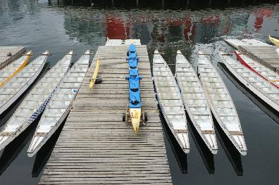
Payment is due by May 28, 2019 as we are required to forward the full program cost for our crew to the Sunnyside Paddling Club by June 1st. This year, like last year, all payments will be handled by our wonderful treasurer, Ingrid Schurr. Her email address is ingridjschurr@gmail.com

You can e-transfer your payment to: Ccbdragonboattoronto@gmailcom or mail a cheque made out to CCB Dragon Boat Toronto, and send it to
10 Guildwood Parkway Unit 432,
Scarborough Ontario m1e5b5.

After you register with Myra or Tammy, please let Ingrid know what method you are paying by so she can watch for your payment.
What’s included?
- Life jackets
- paddles
- Coaching
- Safety staff & motor boat.
- 11 practise sessions. 1 regatta.

Hey folks, it’s a real deal!
Also, for paddlers accompanied by a guide dog, our Dog Squad volunteers will be available to care for each dog while you’re paddling.

Getting to the Sunnyside Paddling Club Practice Site:
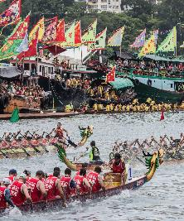
The Sunnyside Paddling Practice site is located at 1755 Lake Shore Blvd. W.
For WheelTrans users, the best drop-off location is Pizza Pizza at 1771 Lake Shore blvd. w.
Volunteers can meet you there for a short walk to the actual paddling site.

For TTC users and those driving to the paddling site, please go to the following website, https://www.sunnysidepaddlingclub.com/
For directions to the site and parking information.

Space is limited, so if you’re longing for some fun in the sun and relaxing summer evenings at Sunnyside, while enjoying the wonderful sport of dragon boating, please register as soon as possible and plan to hang out with us at the beach on those lovely summer Monday evenings.

Paddles up!
Myra, Ingrid, Estelle and Tammy
CCB Toronto Dragon Boat Executive

CCB Needs Report on Accessible Technology++
The CCB’s Needs Report on Accessible Technology has been released. You can find it on our website at ccbnational.net. Special thanks to the 453 respondents from across Canada who took the time to reply to the survey. The results and recommendations, as presented in the final report, are already having a huge impact on the Governments mindset and will impact on future decisions on legislation effecting Canadians with vision loss. Please forward your comments to CCB National at ccb@ccbnational.net. We will keep you updated as to our progress through this newsletter and social media. Once again thank you for your participation.

In Memory++

Don Mitchell CCB Kawartha White Cane Club
The Kawartha White Cane Club lost one of its founding members, Don Mitchell, on April 6 2019.

One of the original members with our club, He took on all roles within the club, and was the president for many years. Don was also a member with the lions clubs CNIB and the Omemee Lions club. He was a wonderful person with a big heart, who loved to offer a helping hand. Don will be missed in our club.
Goodbye Don

Submitted by
Shelly Scott, President of the White Cane Club

Jeanie Krigel CCB Windsor/Essex Low Vision Social & Support Group
Jeanie Krigel, one of our founding members for the Windsor CCB group has passed away. She was very active with the group, blind bowlers, CNIB, and a dedicated volunteer.

She was also supportive and active with tandem bikers in Windsor and with lawn bowling. She won several metals which also took her to different places in Canada and into Europe to compete.

She was great with technology and enjoyed Life to the fullest including being a wine connoisseur. She was smart, savvy, full of knowledge and advice. She will be sadly missed by all of us.

With great sadness,
Helen Medel, President CCB Windsor social support group

Assistive Technology

Supersense App for Android++

To our Android followers here's another helpful Artificial Intelligence app.
We have just released Supersense, a new kind of Android app for the visually impaired and the blind. It is very different from SeeingAI, Envision, and others. Supersense helps you locate an empty chair, a door, a trashcan, and many other useful things. It does all of this offline, without an internet connection. If you have ever had difficulty finding objects around you, you may want to give this app a try.
We heard some encouraging words from our testers so far.
- "Excellent app and excellent concept indeed! I've fallen in love with the app!"
- "I have tested it out a few times and I love it. I was able to independently find my house dumpster for the first time!
- "Many thanks for your app. I use it to find stairs on our house block or in front of the mall."

You can try it for free and then there is a monthly subscription. We will soon add yearly and lifetime subscription options.

The app works on phones with Android 6.0 and above. The iOS version will be released this summer.

We are trying to empower people with visual impairments and blindness to navigate and use their environments more independently. I would love to hear your feedback on how this app can make that happen better.

Looking forward to hearing from you,
Emre Sarbak
Co-founder | *Mediate* http://mediate.tech

Donna's Low Tech Tips, Privacy protection ++

We are constantly striving to protect ourselves from scams and scammers, but most of all we need to ensure that our privacy, confidentiality, and independence are kept safe from prying eyes and those who thrive on destroying our right to these precious commodities.

Signing cheques
When you go to sign a cheque, there are some banks that provide raised line cheques but the problem here is that even if you can use these raised lines to help guide you, a vision impaired person has no way of telling whether or not the pen is writing. That is, whether or not the pen has ink enough to write.

Here, you need a trusted person to help you complete your cheques but if you do not have access to someone you trust; it is probably best to visit your banking institution and seek assistance of a staff member.

To contact me, send me an email at info@sterlingcreations.ca and I'd be happy to respond.

Black & Decker Talking Toaster Oven ++
Blind Mice is proud to introduce the Black & Decker Talking Toaster Oven!
Gain more Independence in Your Kitchen!
-Set Cook Mode
- Set exact cook time!

This modified Black and Decker, counter top, feature rich talking toaster oven which allows persons with low or no vision to cook foods independently. Select cook mode and set the temperature and cook time! The Talking Black & Decker Toaster Oven has a 12" x12" x 8.5" cooking chamber and 1200 Watts of cooking power. It is simple to operate and its high quality male voice is clear and easy to understand.
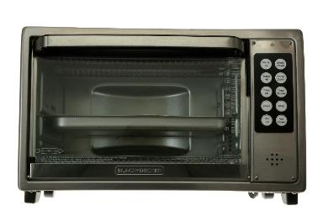
Specifications
4 cook modes: Bake, Broil, Toast, Warm
Bake mode temperature range 200-500F
Broil mode temperature range 300-500F
Toast mode temperature range 300-500F
Warm mode temperature range 125-500F.
Convection and regular bake mode.
Clear and intelligible male voice
8 volume level settings
Timed cooking only: 5min to 4 hours.
Integrated talking cooking timer
Embossed keys make them easy to locate by touch.
Simple to operate.
One button presses inform user of current settings and remaining cook or kitchen timer times.
10 Amp current draw at 120VAC (1200W)
Dimensions: L 18.25 x W 14.0 x H 11.5
All stainless steel construction with glass door.
Weight 18lbs
Warranty
1 year parts and labor.

In the News

Beepball: Leveling the Playing Field for 125 Years++
“The boys have modified it somewhat so that they have a right good game,” reported KSB teacher William Frederick at a meeting of teachers of the blind in 1894. The first recorded game of baseball for people who are blind was actually played here in Louisville, at the Kentucky School for the Blind (KSB), in 1894.

The Museum at the American Printing House for the Blind is celebrating 125 years of baseball history when it hosts a demonstration beep baseball game at the Kentucky School for the Blind on April 27.
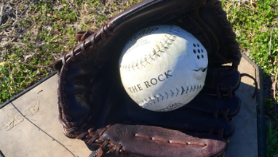
“The pitcher stands about eight feet from the batter and counts one, two, three. At three he lets the ball go, and I think that twice out of five times the batter will hit it. When he hears himself strike the ball he runs.”

Back then, the bases were trees, and, yes, players occasionally ran smack into them.

Various other ways of adapting the game of baseball for athletes who are blind were attempted over the years. In one, the runners kept one hand on a shoulder-high cable that circled the four bases. In another version, the ball was rolled along a brick pathway, and the players swung bats like golf clubs.

Now, the game follows the rules of the National Beep Baseball Association, first written down in 1964. There are 32 registered adult teams nationwide, and every year they compete for the World Series of Beep Baseball. The Indy Thunder (Indianapolis) is the 2018 world champion.
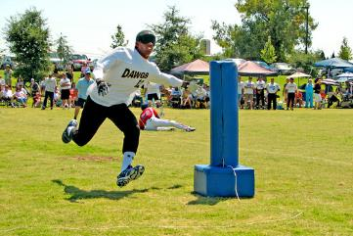
There is currently no team in Louisville, although several people would like there to be one, including Randy Mills, who is coaching the Kentucky School for the Blind (KSB) team for the April 27 demonstration game. Retired from a career as an adaptive physical education resource teacher with JCPS, Mills took on a stint last year as an interim physical education teacher at the Kentucky School for the Blind. Since early February he and a dedicated troop of 14 young athletes in grades 6-12 have been practicing beep baseball.

The ball is similar to a softball, with the beeper buried deep inside. Teams number six players. The pitcher is on the batter’s team, and the ball emits a beeping noise once it leaves the pitcher’s hand. The runner runs to base – or rather, directly into it, since the base is made from sponge rubber and is about four feet high. The base buzzes so the runner knows where it is, and the ball continues to beep while it is in play.

It’s a very noisy game, but the fans in the stands have to keep as quiet as possible so the players can hear the beeping and buzzing. Instead of the good hand-eye coordination prized in some sports, these young athletes need good “hand-ear” coordination.

Players score a run by making it to a base before the other team locates the ball. When a fielder focuses on the sound, he or she often dives headfirst onto the ball, trapping it on the ground.

All the players wear blindfolds. Fact is, most people who are blind can see a little, even if it’s just light and shadow, so wearing blindfolds level the playing field. Gary Mudd, who is blind and a vice president at the American Printing House for the Blind, says he “grew up on baseball” and he’s looking forward to the game at KSB. “It’s America’s game,” he says. “Everyone should have an opportunity to experience it.”
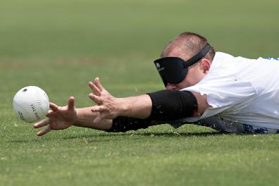
Too often, people focus on the things that people who are blind can’t do, or on the precautions, they must take.

On the beepball field, kids know no obstacles. They’re running and swinging as hard as they can, just like any player on a major league team. Sure, it’s a blast to play, but it’s also an opportunity for them to show what they can do as athletes.

Mills hopes that, given this taste of baseball, the young players will go on to participate in the new Louisville Miracle League, which is intended especially for kids with disabilities. Games will take place at the fully accessible baseball field, playground, and splash park in Fern Creek Park.

#worldbookday2019 ++

Can everyone buy your books at the same time, at the same price and in the same format irrespective of their ability?
Now is the time to make sure that they can!
In the UK and Ireland World Book Day is on Thursday 7 March 2019. This date came about after serious thought and lengthy discussion to ensure that we were making the best decision for all participants and our supporters. We take into consideration religious holidays, school terms and potential conflict with other charitable activities.

In other countries World Book and Copyright Day takes place on 23 April. Celebrations take place all over the world to recognize the magical power of books – ‘a link between the past and the future, a bridge between generations and across cultures. By championing books and copyright, UNESCO stands up for creativity, diversity and equal access to knowledge…’

For international information on World Book Day, please visit:
www.unesco.org

Sidney Crosby is only Cole Harbour’s second-best hockey story ++
This is the story of Kelly Serbu, who noticed some issues with his eyes in his second year of junior hockey and kept right on playing — even as he went blind.

He never imagined professional hockey in his future. As tough guys are inclined to be, he was a realist. Illusions get dropped with the gloves. He had thoughts about playing college hockey — maybe — maybe a senior league after that. He understood, though, he was never going to play in bigger games than he would that spring with his Halifax Jr. A team. They had a shot at nationals, the Centennial Cup, representing the Maritimes.

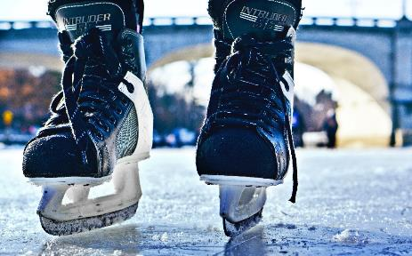
He had a secret, too. Mostly a secret, anyhow; just a couple people knew. A clue, a hint: He had been the guy who made the rounds, picking up teammates in his old rust-bucket and driving them to the rink; and then, one day, mid-season, he lost his license and took the bus or counted on rides.

The secret was undeniable, unavoidable, beyond his control: He was going blind. This he had been told. This he had tried to steel himself for. He opened up to a couple of teammates. They were shocked. They saw no telltale signs. They couldn’t quite process it when he told them the specialists’ diagnosis: he’d be legally blind by age 40. In actuality, Kelly Serbu, age 18, was losing his sight faster than he knew. He would be legally blind by the season’s end, but improbably — no, impossibly — blindness was something that he played right through.

It’s easy to understand how people would be inspired by Serbu but just about impossible to divine how he did the things that inspired them. The odds against any young person making it as far as Jr. A are long, and to a national-championship tournament that much longer still. The baseline, the all-things-being-equal:
They might bump up against the ceiling of their talent. The complications, the bad bounces both literal and figurative: Circumstances might work against them; myriad challenges might stand in the way. The odds of Serbu’s vision loss were one chance in 10,000. The odds of a legally blind kid playing Jr. A hockey are exponentially greater than that. And beyond that, almost everybody, his teammates included, had no idea, begging the question: How could they not see that he could not see?
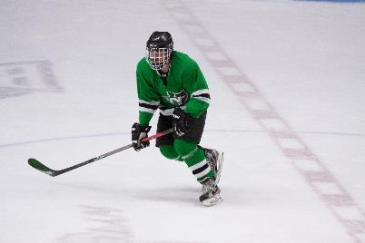
Losing his vision forced Serbu to really focus on his goals, buckling down at school while continuing to play hockey

In his first year at Saint Mary’s University, Serbu could sit in the back of class and read every word on the blackboard; he wore contact lenses but with that necessary correction the world was crystal clear. When second year started, however, he again took a seat in the back of the class but this time couldn’t make out a word. It was a nuisance more than a worry. Reading words on the page was much more of a problem — it seemed like there was a fog around each letter. School wasn’t going that well and he was dropping classes, which would land him on academic probation. He tried to make sense of this sudden change. He had worn glasses or contacts since he was in high school. Applying Occam’s Razor, he assumed he had a bad prescription. Is No. 1 or No. 2 clearer? Different prescriptions weren’t improvements. He made appointments with specialists who struggled to come up with a cause. They went through his family history and he underwent a variety of exams and tests.

All this played out over a few months while Serbu played his second season of Tier II junior hockey with the Halifax Jr. Canadians. Any blurriness hadn’t affected his play, not that he could tell at least. He didn’t even mention it to coaches or teammates, not even the guys he would pick up in that old rust-bucket and drive to practice.

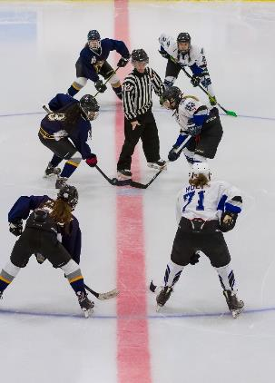
In mid-season, Serbu went with his mother to an appointment with an ophthalmologist who had no good news. They were kept waiting for an hour and a half, his mother growing more anxious by the passing minute. Finally, the specialist brought them into the office. “What I remember was that he was very cold, the way that he gave me the diagnosis,” Serbu says. “He told me, ‘You have Stargardt, a genetic disease, an incurable degeneration of the maculas, the centre of your retinas. You will be legally blind by the age of 40.’ He told us that my loss of vision could be gradual or it could happen fast — that part wasn’t predictable. But the end point, legal blindness that was certain. My mother was crying and I sat there, saying, ‘Ooo-oo-o-kay…’”

The diagnosis served as a call to action and forced him to take stock of his life. “I was shocked by it but I’m not a believer in the idea that everything happens for a reason,” Serbu says. “My parents were big on the philosophy that you just have to deal with the cards you’ve been dealt — things just happen and you don’t just sulk about it. I understood that I’m not going to be able to drive, so I’m going to lose a lot of independence that way. And I understood that I’m going to have to get serious about school — being legally blind I’m not going to be able to even pump gas if I don’t get a good education.”

Serbu says today that he had been “a bit depressed” before getting that appointment with the ophthalmologist, because of his frustrations with school. Hockey had helped him get through that period. The game presented no greater risk to his condition — his vision wasn’t going to get worse by playing. “I had to think about my long-term future, yes, but I didn’t want [the condition] to keep me from doing things that I loved. To that point, Stargardt had no impact on my game. I wasn’t about to give up playing hockey. I just kept it to myself. I didn’t tell the coaches or the guys on the team. I didn’t want it to become a thing.”
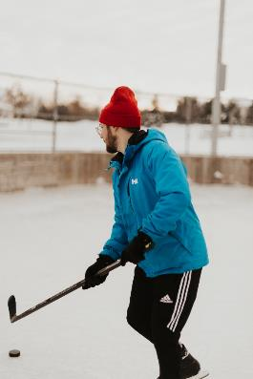
Hunter, Serbu’s best friend on the team, was the first to pick up on it, although it had nothing to do with what played out on the ice. Hunter lived about a half-hour from Cole Harbour and Serbu would frequently drive over to his house. Those visits came to an abrupt stop. “I wondered about him not driving to practice and looking a bit down,” Hunter says. “When I asked him about it, he told me why he had to give up his license.”

Hunter kept his buddy’s condition in confidence for the rest of the season. For his part, Serbu didn’t want to call any attention to himself, didn’t want to have to keep on explaining it to people, and definitely didn’t want it out there, known to players on other teams. “He was always a glue guy, the team guy … it was never about him,” Hunter says. The Canadians won their league championship, then the regionals and wound up going all the way to the Centennial Cup, the Tier II national championships where they lost to the host team Sudbury in the semi-finals. It was a tough way to end their season but made even tougher when they had to watch the Vernon Lakers, a team they’d beat 8-3 in the opening round, hoist the trophy at the end of the tournament. The Canadians’ only consolation was that they had returning talent and were likely going to be a stronger team the next season.

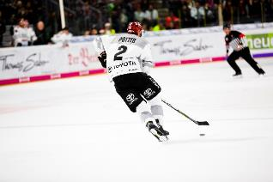
A few weeks after the Centennial Cup, Serbu went for an assessment at the Halifax office of the Canadian National Institute for the Blind (CNIB) — which happened to be across Almon Street from his team’s home arena. Though he had been preparing himself for the certainty of legal blindness by the age of 40, he was unprepared for the results of his exam. “I remember reading the eye chart,” he says. “I hadn’t had tests for a while but vision loss was way faster than we knew. It was literally like a light switch. At the end, the guy who administered the test said to me, ‘I’m sorry to inform you, you’re legally blind.’”

Yes, he had played Tier II junior hockey through legal blindness.

SEEING THEN BELIEVING
Legally blind as his Mooseheads competed for the Centennial Cup, Serbu got by on peripheral vision and hockey IQ

Okay, let’s pause. At this point, you’re asking: How? Perhaps even: HOW?

Think of the ways scouts evaluate players. In the category of intangibles, two words always surface: vision and instinct. To some, they’re interchangeable concepts. To say that Serbu played on instinct alone, though, wouldn’t be fair, either literally or figuratively. Serbu explains: “Stargardt just affects my central vision, but it doesn’t affect my peripheral vision. I see someone with the puck on the wing out of the corner of my eye, but if I’m going down the ice, I can’t read signs, can’t read the numbers and the score. If I’m in the penalty box and the coach is waving, I have to have someone telling me whether he’s waving for me to come to the bench or stay out there. But I had great coaches along the way. I had been taught where to go and what to do on the ice. I go to the front of the net and bang away.”

Serbu could see the game on the periphery and visualize the rest, where he had to go, where others should be. He had to be hyper-aware, never losing track of who was on the ice with him, where his defensive assignment was at any given time. Said his coach, Jim Bottomley: “He was always a smart player — a high hockey IQ. He knew where to go on the ice … where he could be effective and help. If you didn’t know he was legally blind watching a game, you’d have no way of knowing. I was coaching him and I didn’t know until I was told.”

Serbu only let Bottomley in on his secret when he came back for his last season with the team, which changed names that fall to the Mooseheads. Serbu was adapting as he played. He started using a stick with a bigger blade, giving him a better chance at controlling passes. He told teammates not to saucer the puck to him — those were the toughest passes for him to pick up. That year turned into a season of plagues for Serbu, though none of them had anything to do with his loss of vision, just the usual occupational hazards, the workplace bumps and breaks that visit players unafraid to put themselves in harm’s way.

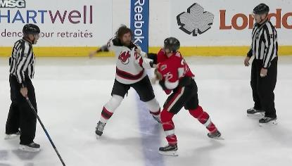
It started auspiciously: Serbu scored on the first shift of the Mooseheads’ first regular-season game in Amherstburg. But a few minutes later, a bit of miscommunication on the bench would wind up putting Serbu on the sidelines. Bottomley leaned over Serbu’s shoulder and said: “Don’t fight that guy.” Maybe it was the noise of the crowd, maybe it was teammates shouting beside him, but Serbu only made out the last three words, with “that guy” being, as he remembers it, “some big steroid monster who had come over from the OHL.” Serbu wound up being tossed out of the game but not before he suffered a broken nose. “Exploded, blood everywhere,” he says. Then, a month or so later, a worse injury. “It was an innocent play, just on our power play, a bit of a bump, that broke my arm right through,” Serbu says. “I still have the plate in there.” That winter the Mooseheads were a powerhouse in the Tier II ranks, seemingly a sure bet to regain the provincial league title and return to the Centennial Cup, but Serbu was out of the lineup more than he was on the ice.

Time on the sidelines is never fun, especially in the junior ranks where players are ever on the clock — Serbu’s last season of eligibility was ticking down. He had always been realistic about his place in the game. His vision loss hadn’t changed how he played but it had changed him away from the rink.

He poured himself into his schoolwork, understanding that if he wanted to graduate with his class and go to graduate school, he was going to have to spend hundreds more hours than the average sighted student hitting the books. Though a Tier II player might be able to make the jump to Canadian university hockey, he couldn’t manage playing for the varsity team along with a full course load and vision loss. Uninterested in sacrificing his educational and career ambitions, he believed that his last year of junior represented his last, best shot at playing hockey at an elite level.

HEADLINE NEWS
Even after the press got wind of his failing sight, Serbu downplayed the extent of his vision loss

Serbu’s frustration at not being able to play was compounded just before his scheduled return to the lineup in March when he became what he had hoped to avoid: a story. How it got out he still doesn’t know — everyone on the team knew tipping off a reporter was no favour to him. First the Halifax Chronicle-Herald picked up on it and came knocking. “LEGALLY BLIND BY THE TIME I’M 40,” the headline read, with the first two words in 48-point type. Serbu slow-played his condition — while he laid bare what Stargardt holds in store for those afflicted, he held back how advanced his vision loss already was. “Basically, it means my eyes are deteriorating,” he said.

When he finally did get back in the lineup, it took him little time to round into form. There was little doubt that the Mooseheads were going to roll through the Nova Scotia teams — they won playoff games by double digits and in one newspaper account an opposing coach lamented the fact that his own players asked him not to send them out on the ice. Serbu picked up a goal here and there, playing his usual safety-last game, setting up in front of the net and screening the goalie so neither of them could see the shot from the point.

In the seventh and deciding game of the regional final at the Halifax Forum, with a trip to the Centennial Cup on the line, the Canadians beat the Charlottetown Abbies 7–4. Serbu didn’t figure in the scoring but he made a big contribution, dropping the gloves with future NHLer David Ling, who turned his stick upside down and pretended it was a white cane as he left the ice. The last laugh, though, was Serbu’s as Ling, one of the Abbies’ best scoring threats, was tossed from the game. These days, for good or ill, enforcers are an endangered species and their contributions have been minimized if not dismissed outright.

But this was 1992; a different set of values was in place. Says Tom Hunter: “Even before anyone knew about his vision loss we rallied around him a lot of times. After [the Ling fight], though, it went to another level. Nobody on our team got more respect in the room … the way he stuck up for teammates.

When we needed something done, when Jim [Bottomley] tapped him on the shoulder, he’d go. He was brave, fearless … he had to be just to get out there at all.”
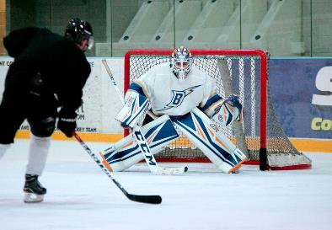
“If there was a chance for him to play, we wanted him to play for us.”

When the Halifax Mooseheads made it to the Centennial Cup, this time in Winnipeg, Serbu was once again a story and none too pleased about the idea. He told a local newspaper reporter that he had answered “tons and tons” of questions about Stargardt and playing hockey with vision impairment. You could read between the lines that he was tired of it. “It doesn’t affect me that much,” he said. But with no more than five games left in their season, the Mooseheads’ coach spilled on what Serbu had meant to the team. “The work he puts in and the sacrifices he made definitely picks the other guys up,” Jim Bottomley told Ed Tait of the Winnipeg Sun. “One of the things we talked about before this tournament … was that this could be the last time this kid ever plays hockey. We want to [win the championship] not only for ourselves but for Kelly.”
The tournament started off as if scripted: Serbu scored three goals in the Mooseheads first two games in the round-robin section. But again, the team made it only as far as the semi-final, where it was knocked off by the Thunder Bay Flyers, the eventual champions and a team that Halifax had beaten 9–3 in the opening round.

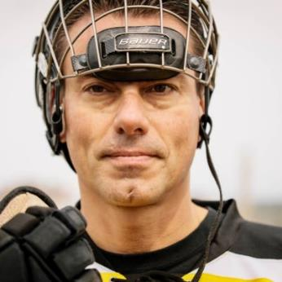
Though he had been telling everybody that this was the end of his competitive hockey career, he wound up being drafted by the senior team in Bridgewater.

“I was playing for Bridgewater at the time,” says Rob Forbes, who was an assistant coach for Halifax in Serbu’s first Tier II season. “We took him with our first pick. He was one of those guys who had so many positives … a great skill set, fearless, played hard, played smart. If there was a chance for him to play, we wanted him to play for us.”

KEEPING HIS COOL
2 Kelly Serbu

On the ice in Jr. A, even teammates failed to notice Serbu had lost his sight. The same thing happens today with judges and fellow lawyers in the courtroom
…story to be continued in the June newsletter.
By Gare Joyce

www.ccbnational.net
ccb@ccbnational.net
1-877-304-0968

