VISIONS

Canadian Council of the Blind Newsletter

October 2019

“A lack of sight is not a lack of vision”

President’s Message++
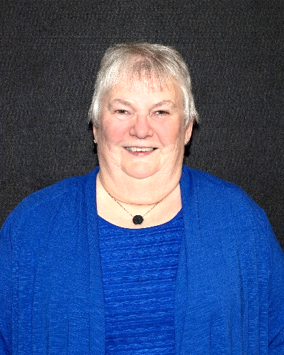
1Louise Gillis - CCB National President
Welcome to the fall edition of Visions. I expect that most chapters are back up and running into a busy season of activities. There are some major events coming up in October like the Federal election! This is the time to speak to the candidates either at your door, in their office, by letter or at organized debates or town hall meetings in your area.
The CNIB has sent out some important points for you to talk about to the candidates that I will list here followed by some more that CCB also feels strongly about.

These items are very important to all - work with provincial governments to create and deploy a national assistive devices program, so that no matter where in Canada a person with a disability lives, they will have access to needed assistive technology that is affordable; enhance available and affordable internet access for all Canadians with sight loss – both mobile data plans and home internet access; invest in beacon way-finding technology offered at all Government of Canada buildings and facilities funded with federal dollars; only procure materials, devices, facilities, services, and systems that are fully accessible for Canadians with sight loss.
We also recommend that members and your families/friends consider the following information that we have worked in conjunction with Best Medicines Coalition to compile.

The current patchwork of prescription drug coverage in Canada, with widespread inequities and shortfalls, is insufficient to meet the needs of all patients. Too often the result is compromised care and limited outcomes at great cost to taxpayers and suffering to individuals and families.

Reform proposals, including the implementation of National Pharmacare, must address needs and inequities, levelling up programs to a high standard of comprehensive care, ensuring the most critical disparities are prioritized and resolved. Importantly, reforms must not leave any patient worse off.

All patients, without exception, must be able to obtain medically necessary medications in a timely manner. Medicines continue to grow in importance in saving lives, reducing suffering, extending years of good health and improving quality of life.

Comprehensive means that all patients, without exception, must be able to get the medications each requires. This includes those with chronic, complex, difficult to treat, and/or rare conditions. Comprehensive must include specialized drugs, and medications considered curative or breakthrough.

So-called essential medicines lists may have merit as a stop gap measure, but would leave too many Canadians without adequate coverage, especially if adopted in isolation. Rare diseases warrant a specialized approach such as the creation of a national strategy for evaluation and funding. Eye treatment can fall into this category therefore patients may not receive the necessary treatments for such conditions as wet AMD and conditions caused by diabetes which can lead to sight loss
Canadians should consider change proposals as they are presented and evaluate by asking the following questions:
Who will be covered?
To what extent does it cover everyone and will the needs of those who are currently falling through the cracks be addressed?
What will be covered?
To what extent is it truly comprehensive in terms of numbers and types of drugs covered?

During September we met with Barrier Free Canada to work on some ideas on how we can move forward following the election to ensure that the Accessible Canada Act will continue to move forward in a positive way. We also attended the Consumer Access Group (CAG) meeting by teleconference.

CADTH (drug review in health) has established an advisory group to work to develop a system for the proper introduction of Biosimilars into the formulary for patient use. Along with a representative from the Ophthalmology Society I will be representing the ophthalmology segment to work with several other persons from four or so organizations of major health issues to ensure the introduction of biosimilar drugs are properly listed in the formulary for use.
CCB was represented at the WBU meeting in Chicago where we welcomed several individual countries from the Caribbean into our region. There was more discussions on quiet cars, electric scooters and bike paths which a committee of the global group will be working to find solutions to the issues and dangers of these items. We are still awaiting news from the Bahamas as to the status of persons with sight loss and how we can assist in recovery from hurricane devastation.

I hope you will find some interesting articles in this edition. It is time to get membership dues in for 2020 and for curling in the AMI Curling Championship in February.

Louise Gillis, National President

Announcements

++ Introducing Ez2see Products for the Vision Impaired!

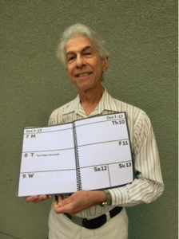
Are you looking for a low-tech solution to managing appointments?

Ez2see products produce easy-to-use items, including a very clear and easy to see calendar, which can be used as a daily planner or day timer.

The 2020 calendar is available now!

Another product are post it notes with a black boarder, so someone with limited vision will not move off the edge when writing notes.

Edward Cohen, the low-vision entrepreneur behind these products states, "As someone dealing with declining eyesight, I bought weekly calendars claiming to be large-print. Yet I still had to write over the numbers with a bold marker to make them easier to see. Also, their writing space wasn’t large enough for me to write big. That frustration gave birth to this calendar."
2 Edward Cohen

The unique features of this calendar are designed specifically for anyone who needs large, high-contrast print and/or an extra-large amount of writing space.
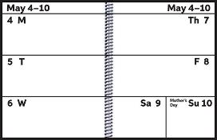

Calendar Features:
• 8.5" x 11” pages on heavy-weight paper
• Laminated covers for moisture-resistance and durability
• High contrast black fonts more than 10X larger than newsprint
• Huge daily “cells” each nearly equal to two 3”x5” cards
• Black page edges – no more writing off the paper
• Six wide bold-lined pages at the end for your notes
• Black spiral bound so you can fold it in half and lay it flat
• Runs from December, 2019, to mid-January, 2021
• About as thick as a standard wooden pencil

Here's what people are saying about the Ez2see calendar:
"I do love this calendar and find it so easy to use and see. You have thought of everything by making the cover water resistant, making a place for my Id if it's lost, and monthly calendar for those wanting to see the entire month. Plus so much space to write daily stuff. My Rehab teacher is trying to get me to use the calendar on my phone, but I'm not too thrilled about it. Guess I am a bit old fashioned about some of this technology. Ha! Keep making it!"
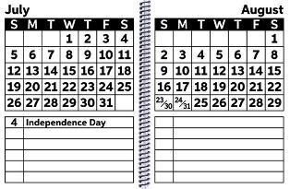
"I have found your large print calendar exceptional! Best on Market. Very large and bold print and big spaces for writing. I have referred other people to your product. Thank you for being there for low-vision people. A product I can use."

"Your product is great and has given my husband his “freedom” back – he knows when his appointment are without needing to ask anyone. He loves being in control of his schedule and life. Independence – a very good thing to keep as long as physically possible!!"

For more information on Ez2see products, or to order one of these quality items for yourself or a friend, please visit the following website:
www.ez2seeproducts.com
or call: 929-269-4740

CCB is helping you to get to know your assistive technology++:

GTT (Get Together with Technology), Sponsored by the CCB, holds monthly Beginners National Teleconference Calls, , where we will focus on the needs of computer, smart phone and tablet users who are just starting out and who want to know only the basics of accessible technology.

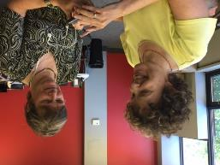
These calls are one hour in duration and will take place during the day at 2:00 PM Eastern Time on the fourth Tuesday of each month.

Calls take place over the accessible Zoom Conference system, which allows participants to dial in using their landline phones, smart phones or computer.

If you are interested in joining the conference calls, or starting a GTT group where you are, where participants can learn and share their knowledge on assistive technology, and all things accessible, please get in touch with Kim Kilpatrick through the CCB National Office.

CCB Mississauga VIPs Meet and Greet++

Come meet the members of CCB Mississauga VIPs!
Location: CNIB Mississauga Office, 300-50 Burnamthorpe Rd. W.
Date: October 26th 11:00am – 1:00pm
Contact the Chapter at: 416-604-5663 ccbmvip@gmail.com

A Pre-Launch Tour of Ottawa’s New Light Rail Transit System:++

On Friday August 30, a group of people made history as they walked and wheeled their way through the stations and rode the rails of Ottawa’s brand new Light Rail Transit system on a pre-launch tour.

Much effort had gone into making stations and trains accessible. City of Ottawa staff were eager to show us around and to receive our feedback.

CCB and other local organizations working with those who are blind/low vision had collaborated with the City of Ottawa during the LRT's construction period. We had asked for a pre-launch walk-through and welcomed the opportunity to take a guided tour before it opened to the public.
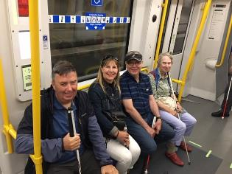
3 Wayne, Bronwyn, Pierre and Fran on the LRT
Wayfinding strips along the floors guided those with vision loss to elevators, ticket machines, train platforms and out toward bus stops and taxi stands. These wayfinding strips included “Decision points,” (squares with truncated domes) to alert passengers to changes in direction. The stations have different levels. Elevators have both Braille and easy-to-read/tactile signage, and we were assured that these elevators would also ‘talk’ before launch day.

The ticket machines are similar to ATMs, as functions could be voiced when using the keypad and wearing earbuds. We were shown how to use the fare-gates and where to place our cards over the reader. Instead of turn styles, saloon-style doors would flip open and close when entering and exiting the ticketed areas. The accessibility fare gate is wider than the others. During busy periods, passengers will hear the beeps as access cards are scanned and the clunk sound of the fare gates as they open and close—these will serve as excellent sound cues. The Transecure area is brightly-lit, with seating, Braille and tactile signage and telephone as well as video access to assistance if needed.

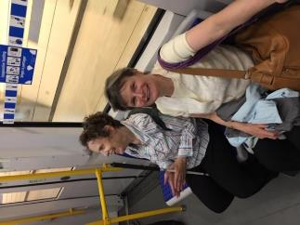
Some stations have trains coming and going on either side of the platform while others have a single track with a wall on one side. Having the opportunity to explore different station layouts reduced our fears of falling off a double-track platform. Some stations have more than one entry/exit point, therefore, we must give ourselves time to learn our way around. Trains run east and west, with thirteen stops. Incoming trains are announced on the west sides of the platform for those heading west, and on the east side for trains heading east, another great sound cue! The platforms have large, yellow strips with truncated domes at their edges, and there is a very small gap between platform and train. We were told that trains will typically be made up of two cars, and, as the train always stops at the same spot, vertical yellow posts will prevent people from accidentally stepping into the space between the cars.

A train pulled in to the station, and we all piled on like excited kids on a field trip. A red light over each train car door indicated doors opening and closing. We were told that there would be eight seconds to enter or exit the train. We all suggested that a louder chime be added so that those who could not see this light could orient themselves to the doors, and know when they were opening. Each train has several doors and each car can carry approximately 300 people. Inside, we found the priority seats that flip up and down theatre-style, making room for wheelchairs, strollers, shopping buggies etc, and offering plenty of flexible space for service dog /guide dogs’ toes and tails. There were front-facing, side-facing and backwards-facing seats and plenty of poles for standing passengers to grasp. There were arrows along the floor, and the announcements were clear and descriptive, in both English and French. As the doors will open on either sides of the train, depending on the stop, we all emphasized the importance of having a very audible chime to indicate on which side we should exit.
4 Kim and Shelley have fun on the LRT

Discussions took place around having to locate and push a button to open train car doors inside and out at certain platforms during off-peak hours. We do not have a definitive answer and questions still swirl about this concern. Along with those in the blind/low vision community, people with dexterity or mobility issues may also face barriers when entering or exiting the trains without automatically-opening doors.

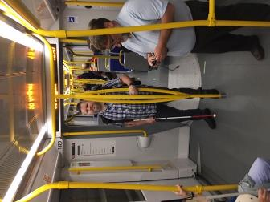
Some of the stations we toured have washrooms that were equipped with grab-bars and are big enough to accommodate a guide dog, a wheelchair and/or an attendant. We had difficulty locating the button used to lock the door, and could not distinguish it from the button used to summon help—that could be interesting!

The LRT opened to the public on Saturday September 14, with existing bus service running until October 6. Like any transition, getting used to LRT will take some time and practice. Many of us plan to play tourist, taking some time to get to know the stations that we will frequent, trying the trains, learning new bus routes and adjusting our travel plans. While some forms of information such as visual maps will be inaccessible, there are going to be other sources that we can use. We can call upon services and supports, such as Orientation and Mobility instructors and guide dog trainers. As our community is very strong, it is likely that the early adopters among us will waste no time in sharing information, and will tell others what we have learned. Several blind/low vision passengers have already been aboard, and found that, while it is a learning curve, it is not nearly as daunting as we had thought. Happy travels!
5 Dwayne Morgan and David Pepper

Summary report of the Elections Canada TeleTownHall held on June 6, 2019 ++

This TeleTownHall was held countrywide and was hosted by the Canadian Council of the Blind (CCB) and Sterling Creations in collaboration with Elections Canada.

The main speaker gave an outline of some of the services that Elections Canada is planning to offer to blind, deaf/blind, and vision impaired electors for the upcoming Federal Elections to be held on October 21 2019.

The long term approach by Elections Canada is to have a universal design approach in terms of providing and designing their services.

Elections Canada has come a long way but it recognizes that there is still a lot of work to be done.
In 2015 Elections Canada conducted an extensive review of all of its polling stations across Canada which totaled about 27,000 and the emphasis was placed on accessibility. A criteria of 35 check lists were developed in collaboration with the community along with returning officers. 15 of these 35 check lists were mandatory and a 98% accessibility compliance was achieved.

This process has been repeated for this upcoming Federal Election. Tools have also been made available at the polling stations for persons with varying disabilities. On Election Day, Braille lists of candidates are to be made available along with Braille templates, signature guides, and an easy to grip pencil for easier use are just some of the tools being made available.

Options would include sign language interpretation to be requested by the Tuesday before the actual date of the election (October 21), and to bring along a helper if required.

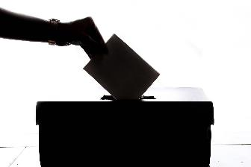
For the previous and upcoming Election, voters with a disability would be asked to identify their needs when they arrive at the polling station. The emphasis for poll workers would be not to assume the needs of any voter but instead, to listen and to react to the need of the voter.
The upcoming Federal election is your opportunity to help choose your representative in Parliament. If you are blind or have low vision, here are some things to consider.
You should have received a voting card in the mail. Check the accuracy of your information as it appears on the card. You will also find the location of your assigned voting place, voting times, and information about accessibility. Various screen reading/magnification apps and devices may help you to access information on your voting card. If you did not receive one, or need to change or update any information, contact Elections Canada by phone or online to do so. Elections Canada can provide information regarding voter registration, and recommends that voters register before Election Day. Visit www.elections.ca and use the online Voter Registration Service. Alternatively, go to an Elections Canada office until the Tuesday before Election Day with accepted ID. You can also register at an advanced poll, or on voting day at your polling station with accepted ID. Your voting card may be used as one of two pieces of ID. There are now many kinds of accepted ID. You’ll find a list on the Elections Canada website.
Visit Elections Canada’s website and enter your postal code to obtain a list of candidates in your riding. Ask candidates about federal-level issues that matter to you.
Make sure that you know where to vote, especially if it is your first time voting, you have moved or the polling station is in a different location from the last election. Make a plan before Election Day to get there. Some voters prefer or may need to vote at advanced polls or at an Elections Canada office. If your assigned polling place does not include the accessibility features you require, you can get a Transfer Certificate to vote in a more accessible location. If you live in a remote area and do not drive, you may consider voting by mail—beware of deadlines as ballots must be sent and received by Elections Canada on time. In some circumstances, electors make arrangements to vote at home.
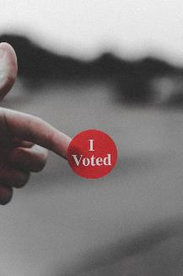
Bring what you need to help you vote—glasses, magnifiers etc. Whether you are voting at an advanced poll, at an Elections Canada office or at your local polling station, there are many tools available to help. These include magnifiers, Braille and tactile voting templates, Braille lists of candidates (on voting day and at some advanced polls) and screens that let in more light. There are larger pencils with better grips—you can even bring your own marker. New Braille templates and ballots are not as likely to slip, however, you may want to ask an Elections Canada worker to come into the voting booth to make sure that your ballot is in place before you vote. Any shape will qualify as a mark.
This year’s ballots include larger text and have been optimized to be more easily read by screen reading/magnification software found on many smartphones and devices. For the first time, blind/low vision voters can use this technology for reading and/or magnification. If you are using a smartphone, you can use BeMyEyes or Aira to help navigate around the polling station. Various sources have said that while the agents on the call can help with navigation, they cannot assist in the polling booth itself as anyone helping a voter to read or mark a ballot must be 18+ years of age and have sworn a solemn declaration to protect the voter’s secrecy. While blind/low vision electors can use screen readers to read the ballot (with earbuds), they cannot take a picture of the ballot, which many screen reading apps do. Also, while your screen reader may read the names on the ballot aloud, marking your ballot independently and with complete confidence remains a challenge. Ask someone how you should correctly fold your ballot after you have voted if you are unsure how to do so. People staffing the polling stations should have received some training on how to help electors with disabilities, and can provide assistance if and when needed.
Once you have voted, you can help to improve the process by providing feedback about your experience. With comments from voters and the implementation of the Accessible Canada Act, it is hoped that Canadians with low or no vision will one day have a completely accessible and barrier-free vote.
For more information, visit www.elections.ca or call 1-800-463-6868
So, please, make your voice heard this October, and VOTE!

Team Dragonfly++
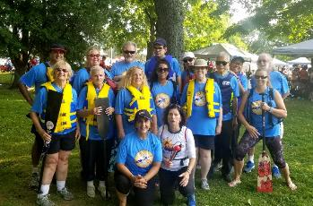
The Christie Lake Dragon Boat Festival held on Sept. 21 was a thrilling way to conclude the paddling season for team “Dragonfly”, & a wonderful learning experience for everyone involved.

“Dragonfly” is a new team made up of beginner & highly experienced sighted, partially sighted & blind paddlers ranging in age from 16 to 76. The team has enjoyed 11 practices this season with the Sunnyside Paddling Club under the awesome guidance of coach & steer person, Ghina Al-Sewaidi and assistant coach Estelle McCalmont.
6 The Dragonfly Team
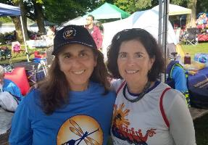
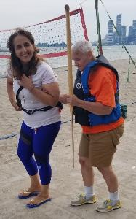
Getting started: We look back to our first two practices at the Sunnyside Paddling Club with good humour as they were a little chaotic in terms of gearing up & boarding the boat, with new blind, partially sighted & fully sighted paddlers milling about, many being unfamiliar with each other’s needs & abilities, the location and practice site routine.) However, this was quickly addressed by one of our visually impaired members who stepped in & kindly prepared an awesome package of guiding tips & techniques for all of us. After that we all felt much more comfortable with each other, confident & safe getting to the dock & on & off the boat. The team quickly became cohesive with everyone contributing to make paddling together a delightful experience.
7 Coach Ghina Al-Swaidi and Assistant Coad Estelle McCalmont.

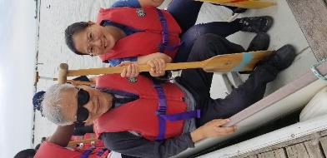
Family Participation: Dragon Boating is one of the few sporting activities that readily lends itself to family participation where one family member is blind or partially sighted. We were very fortunate to have 2 families join the crew this summer, and a third took advantage of drop-in sessions & hopes to join the team in 2020. Our families generously contributed a lot towards various tasks that went a long way to having things run smoothly both during practices & at the Christie Lake Dragon Boat Festival.
8 Getting into the Boat
9 Roly and Aimee
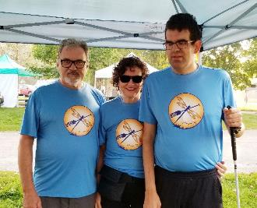
10 Three members of Team Dragonfly
Dog Squad: A very special feature of “Dragonfly” is its established Dog Squad – volunteers who care for guide dogs on a one-to-one basis while their owners are paddling. These wonderful volunteers are invaluable, & their presence goes a long way to making dragon boating an accessible sport for guide dog users, and the practice sessions fun for the dogs as well.

Coach Ghina: We were truly lucky to have Coach Ghina assigned to work with our team this year. She soon caught on to how to instruct those of us who are blind or partially sighted, providing clear verbal directions and demonstrating techniques tactually in a fun and respectful way. She was amazing in the way she worked with our team as a whole, and moved easily among us on the boat, giving individual suggestions & encouraging advice. For many team members, both fully sighted & blind, dragon boating was a totally new experience. Her clear individual instruction and sense of humour, teamed with Estelle’s support allowed us to quickly grasp the basics.

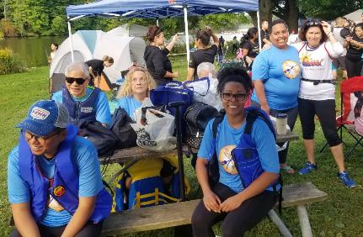
Ghina is also very safety conscious. One evening, just as we arrived at a practice session the wind picked up and the waves were rough. Rather than have the team take chances she had everyone gather on the beach, paddles in hand, and gave an excellent creative lesson on paddling techniques & dragon boat terminology.
11 Waiting at the tents for the races.

As the season moved along there was an increasing flurry of activity preparing for the team’s first regatta. Everyone helped with the necessary arrangements. Team jerseys were designed & ordered by our team treasurer, Ingrid, and we couldn’t wait to show them off at Christie Lake!

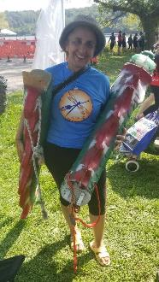
At the Christie Lake Festival some of us who are blind were curious about the dragon heads & tails that are fastened to each boat for the competitions. These parts are not used during regular practices. At the Festival Ghina brought a bright red dragon head & tail to our tent for us to hold & examine – hey, what a wonderful bonus for those of us who are totally blind & curious as all get out!
12 Ghina with the dragon head and tail.

Now it is time to start planning for 2020: “Dragonfly” is a team established by the CCB (Canadian Council of the Blind) Dragon Boat Toronto Chapter.

We have very much appreciated the welcoming support of the Sunnyside Paddling Club & hope we will be able to join this club again next year. We would also love to have Ghina coach us again if she is willing & available.

We are getting ready to welcome new members – both fully sighted & visually impaired/blind, as well as anyone who prefers to stay on dry land, loves dogs & would like to become a Dog Squad volunteer. If you are interested or would like to learn more about team “Dragonfly” and the CCB Dragon Boat Toronto chapter please contact Myra Rodrigues, team captain, at Myrarodrigues@rogers.com.
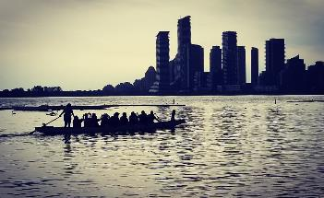
PADDLES UP!
13 Dragonfly on the boat at Sunnyside Beach

Accessible Canada Act Survey++
Please fill out this survey and share it with some of your networks: https://ca.surveygizmo.com/s3/50057094/Accessible-Canada-Act-Survey

It comes together from Holland Bloorview Kids Rehabilitation Hospital and Reena in Toronto. They shared it with us for our network. The survey is to see if there needs to be more education on the Accessible Canada Act nationwide. They are looking to get input from across different regions in Canada. Once all the data is collected by HB and Reena, it will be provided to all parties running in the Federal Election with a public perspective on how to improve the Accessible Canada Act.

It is open to people all Canadians and residents, whether or not they identify as having a disability.

Walk-a-thon in Victoria for braille literacy Canada++

CCB has a close partnership with braille literacy Canada, and on September 14, in Victoria, BC, members participated in the Walk for the Brailler Bounce Initiative!

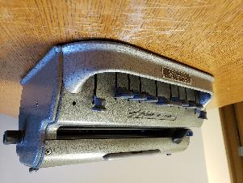
Braille is the key to literacy for the blind, and Braille Literacy Canada believes strongly that all those who can benefit from braille should have access to it. Braille is used to access spelling and punctuation, and enables those without sight to read and write, among other things, phone numbers, household labels and lists. The Perkins braillewriter is the equivalent of a typewriter for the sighted, but unfortunately, these braillers are expensive, costing upwards of $1,000 each, and many people do not have access to government or other funding to purchase these tools. The Big Brailler Bounce Initiative aims to ensure that any unused Perkins Braillewriters find their way into the hands of a blind child, adult, or senior who can benefit from the ability to write in braille. Through this program, Braille Literacy Canada collects unused Perkins Braillewriters, refurbishes them, and re-distributes them to those in need at no cost to any of the recipients. Since this initiative began in 2015, more than 55 braillers have already found new, appreciative homes.

Braille Literacy Canada hosted a “Walkathon” in Victoria to raise funds for the Brailler Bounce Initiative. The roughly six kilometer walk (one kilometer per dot!) took participants in a walking loop from a central downtown meeting location through Rockland and Fairfield and back along Cook Street.

An Evening in the Key of Balance++

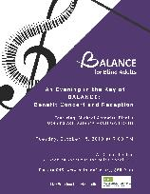
A Benefit Concert and Reception for BALANCE. Tuesday October 15, 2019 Al Green Theatre, 750 Spadina Ave. Toronto. Balance provides customized training and support to facilitate optimal independence and community engagement for persons who are blind or living with sight loss and who often have complex needs for over 30 years in the city of Toronto. Aligning with the BALANCE mission, this Benefit Concert and Reception was established to raise funds to support our incredible groups. This inaugural concert event will host about 250 guests for a music-filled evening followed by an elegant wine and cheese reception.
Featuring: Michael Arnowitt, Pianist
Opening: Susanna McCleary, Fiddle
Hosted by Kelly MacDonald, AMI host and talk show personality
Tickets: www.balancefba.org

Assistive Technology

Narrator Screen Reader Tutorial Podcasts by Blind Vet Tech++

Narrator is a screen reader utility included in Microsoft Windows that reads text, dialog boxes and window controls in most applications for Windows. Originally developed by Professor Paul Blenkhorn in 2000, the utility made the Windows operating system more accessible for blind and low vision users.

In the October 2018 release of Windows 10 Narrator’s functions and keyboard commands have been dramatically expanded. We are now at a point in its development that it will start to rival the third party screen readers we have become accustomed to using in the Windows environment. Finally, it might be said that PC computers purchased off the shelf are accessible to blind and low vision users out of the box.

The latest version of Windows 10 is the October 2018 Update, version “1809,” which was released on October 2, 2018. The below tutorial podcasts only apply to the latest version 1809, so please check to see the current version running in your computer.

How do I know what version I’m running?
To determine whether or not these tutorials apply to Narrator in your computer you can check your version number as follows:

* Press and release the Windows Key and type the word Run, or merely hold down the Windows key and press the letter R.
* In the window that pops up type the text, WinVer and press the Enter key. Typing immediately will replace any text that might already be there.
* The computer will display, and your screen reader will speak the version of your operating system. If it indicates you’re running version 1809 Narrator will function as outlined in these podcasts, however if your computer is still running an older version please disregard these tutorials for now. Press the Space Bar to close this dialog.

The Complete Guide to Narrator on the Microsoft Windows Help Page:
Click here to access the Complete Narrator’s Guide (https://support.microsoft.com/en-ca/help/22798/windows-10-complete-guide-to-narrator ) on the Windows Help Page.

Blind Vet Tech Guides and Tutorials:
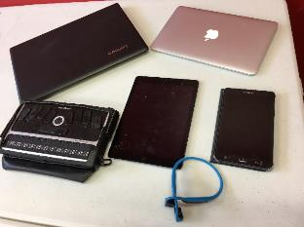
Are you a visually impaired Veteran interested in learning more about technology and adaptive software? Have you received a device, like an iPhone or iPad, from a Blind Rehab Center, but require more information on how to use it? Are you a visually impaired Veteran looking for a network of peers to assist you in determining if updating your device is the right choice? If you answered yes, or simply are interested in learning more about assistive technologies for blinded Veterans, the Blind Vet Tech Quick Guides and Tutorials podcast will assist you. Developed by blinded Veterans aiding our fellow peers adapt to sight loss, Blind Vet Tech focuses on iPhones, iPads, computers, other smart phones, and different technologies Veterans might receive to increase their independence.

To that end, BVT have produced a spectacular series of tutorial podcast episodes ateaching users how to maximize their use of the latest version of Narrator. Below are Hyperlinks to each of the Blind Vet Tech Podcast episodes on the web.

Blind Vet Tech Direct Links to Narrator Podcast Episodes:

* Windows 10 Narrator Basics ( https://overcast.fm/+F2Ux3WiRM )
* Navigating Webpages and Netflix With Narrator’s Scan Mode ( https://overcast.fm/+F2UwBznDs )
* Narrator’s Five Best Windows 10 Fall Creators Update Features ( https://overcast.fm/+F2Uz-fwdw )
* Activating Narrator ( https://overcast.fm/+F2UwQ9D-I )
* Basic Keyboard Commands and Navigation ( https://overcast.fm/+F2UyFyXCQ )
* Quickly navigate Edge, tables, and apps with Scan Mode On ( https://overcast.fm/+F2UzSh4do )
* Learn how to read documents, apps, webpages, and much more with Narrator ( https://overcast.fm/+F2Uym87K4 )

To subscribe to the Blind Vet Tech podcast follow this link. (
https://itunes.apple.com/us/podcast/blind-vet-tech-quick-guides-news-and-reviews/id1073306016?mt=2
)

In the News

Blind man arrested after employee calls police over guide dog at Kamloops gas station++

Ben Fulton has used a guide dog for the last two years and he's used to having to explain to store employees whenever he goes out in public that his dog, Abbie, is a working guide dog.

He's used to dealing with some resistance now and then but a recent stop to a Kamloops gas station was the first time he was ever arrested from an incident stemming from his dog.

"I don't really blame the clerk for calling the police because if you are unsure of the law, that should be who you can call to get things straightened out," Fulton says, who is blind. "I'm mostly upset about the way police handled the situation."

Fulton, 38, was visiting B.C. from Ontario last month and was road-tripping from Vancouver to Salmon Arm to visit his mom on June 16. It was around midnight when Fulton and a friend decided to stop at the Shell gas station in Valleyview along the Trans-Canada highway for a quick coffee break and to stretch their legs.

"We were just basically standing at the counter, putting cream and sugar in our coffee when (the clerk) said 'there are no dogs allowed in the store,'''
Fulton says.

Understanding that the employee may not have seen Abbie was a guide dog, Fulton began to explain she wasn't just a pet. But the employee wouldn't accept Fulton's explanation. So, Fulton took out Abbie's guide dog identification card.

"I was sort of offering for him to take the card," Fulton says.

At this point, the employee asked Fulton if he wanted him to call the police.

"I was trying to explain to him that it doesn't matter what your manager says, it doesn't change the laws," Fulton says. "The law says we are allowed to be here."

The Guide Dog and Service Dog Act says a person with a certified guide dog has the same access to any place an individual without a guide dog has as long as the guide dog does not occupy a seat in a public conveyance or a place where food is served or dispensed to the public. The guide must be held by a leash or harness as well.

Fulton says he agreed that the police should be called.

"I said 'I would love it if you could call the cops' because I was expecting the cops to come and enforce the law," he says.

Two officers arrived and asked him if they could speak to Fulton outside of the store.

"I said 'Well I don't want to go outside because I am standing here at the counter trying to get service,'" Fulton says.

He says the officer asked him a second time to speak to him outside of the building and he declined again.

"The next thing that happened was (the officer) placed his hands on my wrist and said I am arresting you for mischief," Fulton says.

Kamloops RCMP spokesperson Cpl. Jodi Shelkie says responding officers were not aware the man was blind or had a guide dog. The call came in simply as a man and a woman who had entered the gas station with a dog and were refusing to leave after they were told no pets were allowed in the store.

"They began yelling at (the officers) and the employee said the man made gestures at him that made him fear for his physical safety," Shelkie says.

Fulton says the comment about him making gestures is misconstrued. The only thing he can attribute it to is when he tried giving the employee his guide dog identification card.

"That's the only thing I can think of that he could possibly be talking about when I held out my card out for him to look at," he says, adding that he is working on obtaining the security footage from the gas station that night.

Shelkie says the two officers asked the man and the woman to speak outside of the store to deescalate the situation.

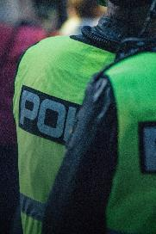
"It's a risk assessment," Shelkie says. "These two people were the subject of our complaints so our focus is to keep the people safe."

Shelkie says officers weren't specifically looking for the dog either.

"They refused to speak to (the officers) in a calm manner or leave the building so. That's when he was placed under arrest," Shelkie says.

Shelkie says the officers didn't know Fulton was blind prior to arresting him and regardless that wouldn't have made a difference in the outcome.

"It was a lawful arrest whether he had a guide dog or was blind or not, he was committing an offence," Shelkie says, adding the offences he was arrested for were mischief and causing a disturbance.

Shelkie says once officers realized there was no more risk from Fulton and they were informed by Fulton's friend he was blind and the animal was, in fact, a guide dog, he was freed from his handcuffs and released without charges.

"The reason he was arrested was to prevent the continuation of the offence and the employee basically wanted them out of the store with their dog,"
Shelkie says.

Fulton says he finds it troubling police say they weren't aware he was blind since he had to hand his guide dog's leash to his friend as he was being arrested.
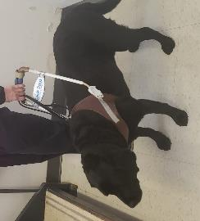
"It's kind of amazing to me that they would have missed the guide dog. She has a distinctive white harness and she's a black dog," he says. "My position is they must (have known) and if they didn't, then there are some serious deficiencies in their powers of observation."

Fulton says he received an apology from the officer who placed the handcuffs on him tightly, but did not receive an apology for anything else.

"There was nothing to apologize for," Shelkie says.

Fulton is a recent graduate of Osgoode Hall Law School in Toronto. He hopes to work with Shell to improve the way companies and local managers understand human rights laws in Canada. This is the first time he has ever had an employee call the police on him over his guide dog, and despite the situation, he would still encourage employees to call the police if they are unsure of the law in the future.

"If you are unsure of the law, you should be able to call the police and enforce the law," he says.
By Karen Edwards

REMINDERS

Membership Madness++
Hi Everyone! Becky from the office here. Membership packages should have been received by the chapters. Independent membership will be sent shortly.

Early Bird Draw Deadline – October 28, 2019
Chapter Rebate Deadline – December 2, 2019
All 2019 Memberships Due – December 31, 2019
White Cane Week Orders Due – December 20, 2019
WCW Insurance Requests Due – December 20, 2019

DON’T FORGET DONATIONS!++
Donations Received in the office in 2019 are the only ones that can be receipted for 2019. Remember to send those donations if you want receipts.

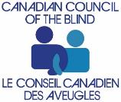
www.ccbnational.net 1-877-304-0968
ccb@ccbnational.net

